
Deep End Cymru Manifesto

Senedd election 2025
- Fair funding for Deep End GP Practices
- More time for patients
- A stronger role in whole system improvement for all patients

Introduction



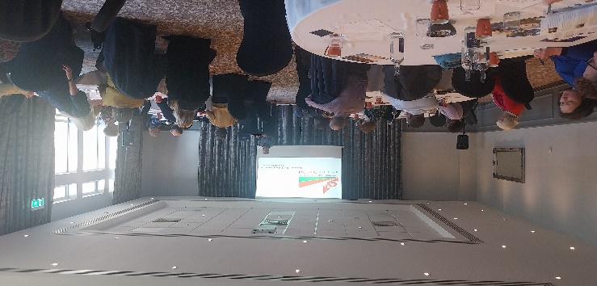
The Deep End Cymru Network came into being on a wet miserable Autumn Day in 2022. The Royal College of General Practitioners in Wales hosted the initial meeting of those interested in deprivation medicine, those working hard in their communities and those wanting to redress the vast inequality in the health care system in Wales, who saw the inception of our grass roots movement.
Originally the brainchild of Dr Julian Tudor-Hart; a GP in the Afan Valley in the 1980s, he saw the inverse care law working at its worst, with many of his patients living much shorter and less healthy lives than those in more affluent areas. He toiled to get equality for his patients, bringing services closer to their homes. More than fifty years later, the inverse care law is no further forward to being eradicated. If anything the erosion of our communities, the overall reduction of funding and the strain on our NHS systems have only served to highlight the failings in our most fragile communities, with a higher percentage of practices folding or merging in deprived areas and an average of 13% more patients per full-time GP.
The current funding model for us is woeful, with less and less funding going to places of greatest need. Our GPs see more patients, who are increasingly unwell, with a reduced ability to manage their symptoms. We see later presentations of serious or terminal diseases and high prevalence of chronic illness, with more interventions and more challenging consultations required by our practice teams to try to help our patients stay well.
Deep End Cymru has found the most joyful camaraderie in these areas, with many of our GPs going above and beyond for their communities. We are tired. There is more burnout among our colleagues, greater concern for our patients and ourselves, but still, we persist, and our movement grows stronger.
If we don't fight for our patients, who will?
Dr Neil James and Joanna Watts-Jane
Chair and Deputy Chair, Deep End Cymru

Our movement
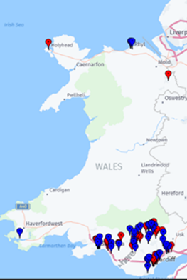
The strengths of our movement lie in our extensive reach into communities. We have first-hand, daily interactions with patients across Wales – we believe this gives us authenticity, and community expertise of up to 400,000 patients nationwide.
We work with and are connected to communities that matter politically, even if their interests are not effectively represented. We see the context around healthcare and understand the complexities of the picture of health in these communities.
Our communities don’t need more labels or deficit descriptions. They are strong, with powerful stories to tell, and have huge assets to be proud of. Were there fair and equitable resources in place, these communities could see real change.

We love our jobs, we love the difference we make, and we want to see others join us to improve the valuable work we do. With investment we could see healthcare in Deep End areas transform and deliver on the ambition we know there is across the country.

Why we need to take action in our communities
Many of our patients should have lived longer and healthier lives.
People are getting sick too young and are dying too young, because of the circumstances into which they are born. Poverty makes people physically and mentally unwell. In mitigating the impact of these determinants of health, we trust the NHS at least to be fair, effective and efficient in dealing with everyone. However, the NHS has been disinvesting in the services that add most value to life (primary care and social care) and we have been distributing our investment inequitably (those who need the care the most, are less likely to receive it).

Inverse Care Law:
“The availability of good medical care tends to vary with the need for it in the population served. This inverse care law operates more completely where medical care is most exposed to market forces, and less so where such exposure is reduced”.
The Inverse Care Law is embedded in General Practice in Wales
In primary and community care, money and resources are inequitably distributed through multiple, embedded and often obscure mechanisms:
  - GP practices in deprived areas everywhere experience significantly greater workload, and their patients have greater unmet need
  - But Welsh GP practices with more patients from most deprived areas receive around 5% less funds (£50-60k a year)
  - Welsh practices with more patients from the most deprived areas are folding at twice the rate of other practices. They are more stressed, because they have more patients and a smaller workforce, with GP partners who have on average 764 (30%) more patients.
  - Outside the GP contract, other funding streams into wider primary care can be small, obscure, short term, with many strings attached and usually not weighted by population need. This has probably exacerbated the Inverse Care Law, especially in the wider primary care team workforce encouraged through the Primary Care Model for Wales. For example, additional Direct Patient Care staff are almost twice as likely to be working in the least deprived areas.

Wales does not have an explicit Health Inequalities strategy to drive more equitable decisions, in spite of multiple calls, and the recent announcement of the intention to become a Marmot Nation (with no plan or funding at the moment). Equity and social justice are said to be a golden thread though all the major health policies and strategies, but we are failing to translate this into implementation, which is where a practical strategy would help.
We would like clear guidance for the public sector in making radical and difficult decisions to move resources into the community and redistribute it according to healthcare needs. The Inverse Care Law is a policy of the NHS which restricts care in relation to need: it is a form of rationing, and we can choose to make different decisions. We feel that this is becoming increasingly urgent and needs to come out of the “too difficult” box.

This Manifesto
This manifesto has been developed by engaging our colleagues and members across the Deep End Cymru network. Since our launch in 2022 we have held a number of Round Table events during which we have heard first- hand the challenges facing practices in Deep End areas.
Complementing this intelligence, we have surveyed and held engagement meetings focused on the development of this manifesto, in addition to receiving expert advice from our academic partners.
Below is a summary of the range of policy proposals raised by our members since our launch, with a focused number of these articulated in the section below.
We are confident our policy proposals are grounded both in evidence and the reality of practising in a Deep End area and believe these policies could transform the health and lives of patients in some of the most disadvantaged areas in Wales.
This Manifesto should be read alongside that of the Royal College of General Practitioners in Wales. Our goals are aligned with those of the RCGP, with our focus specifically on communities with the greatest healthcare needs.

Our proposals for the Senedd in 2026

1. Delivering on fair funding for practices in Deep End areas
Our research shows for every 10% increase in patients registered at a practice that live in the most deprived parts of Wales, a practice’s income decreases by 1%. Practices can lose tens of thousands of pounds a year, affecting their ability to fund the staff and services they need. This is despite such practices facing recruitment challenges, greater demand, higher complexity of patients, and greater levels of multi-morbidity. Addressing this gap could cost as little as £4-6 million a year, less than 0.05% of the entire NHS Wales budget.
Deep End Cymru believes a long-term solution must come in the form of a revision or replacement of the now outdated Carr-Hill formula, in place for over 20 years, making funding for Deep End areas more proportionate to our patients’ needs. Alongside this process we need more short-term solutions. The Additional Capacity Fund supports general practices in addressing capacity constraints, funding 50% of staff posts in practice, and was £4 million in 2024/25.
We call on the next Government to increase investment via the Additional Capacity Fund of £1 million a year targeted towards Deep End practices - with 100% of staff posts from this funding able to be reimbursed including GP posts from 2026/27, with an evaluation after 3 years of the long-term viability of this model.

2. Workforce and demand
Many health workers love training and working in Deep End practices, and health care workers tend to stay in the locality and organisation that they trained in. But we are not targeting training to meet population needs, so not everyone who would benefit gets the chance to do this. We believe there could be an expansion of training placements and a shift towards offering opportunities in Deep End practices, and incentives to train and work in more deprived areas.
We call on the next Government in 2026 to implement an incentive scheme analogous to the Targeted Incentive Scheme for rural areas in Wales, to start 2027/28.
Experience across the UK demonstrates interest and engagement in dedicated health equity training programs is significant; the next generation of GPs and clinicians show great interest in acquiring the skills needed to practice in areas of deprivation and to serve population groups at risk of social exclusion. Yet too often, such training opportunities are unavailable, with the opportunity then lost of motivating and recruiting future clinicians and leaders to serve in these settings.
We call on the next Government to work with Health Education and Improvement Wales, Deep End Cymru and other partners in investing in and prioritising a health equity training programme for Wales, while simultaneously ensuring placement opportunities for undergraduate and postgraduate health practitioners, by 2027/28.

3. Investing in staff and services in Deep End areas
Staff workforces in Deep End areas at present are unable to deliver the continuity of care that we know patients in these areas need and deserve. Wider multidisciplinary teams and services are too often inadequately staffed or equipped to address health inequalities and the Inverse Care Law.
We call on the next Government to invest in ensuring sufficient GP registrars and GPs such that while aiming for a maximum practice list size of 1500 patients per full time GP, Deep End practices have a working maximum of 1200 patients, in recognition of the additional needs and demand on such practices.
Finally, we call on the next Government to ensure the commensurate staffing and services, including third sector link workers, are available in Deep End areas, such that we can work in our neighbourhoods collaboratively with the intensity and support we know we need to respond to the challenges faced by our patients and communities.

Further information
Please contact Deep End Cymru by email DeepEndWales@rcgp.org.uk
Website:
Home - Deep End Cymru
Hafan - Deep End Cymru CY

General practice funding underpins the persistence of the inverse care law: cross-sectional study in Scotland | British Journal of General Practice
Tackling the inverse care law | The Health Foundation
Exploring the equity of distribution of general medical services funding allocations in Wales: a time-series analysis | BJGP Open
Inverse Care Law Study Group
Deep End Cymru Report First Phase 2024
Deep End Cymru Report First Phase 2024
How general practice can save the NHS

