Welcome to our latest Deep End newsletter. Please share with all members of your practice team, we are keen to reach everyone working in Deep End practices.



Deep End Wales Newsletter
March 2026

Health Equity Study Day
Tuesday March 17th 9.30am to 4:30pm, lunch from 1pm
The Towers Hotel, Swansea

Welsh Primary Care teams working in areas of greatest need are invited to a Health Equity Study Day on Tuesday 17 March 2026 at The Towers Hotel, Swansea. This national Deep End Cymru event will bring together clinicians, leaders and partners to explore social justice, health inequalities and practical action in primary care. The programme includes a keynote address from Sir Michael Marmot, interactive workshops with Made by Mortals, and sessions showcasing Welsh and UK initiatives that are tackling health inequalities on the ground.

The Health Equity Study Day sits alongside work being led by HEIW’s Strategic Programme for Primary Care Health Inequalities team, which supports the integration of health equity into education and training across Wales. Current and planned initiatives include the development of a mentoring offer for newly qualified GPs working in deprived communities, the expansion of health inequalities education and training for the wider primary care workforce, and targeted support to improve retention. Together, these initiatives aim to strengthen leadership capacity, improve workforce sustainability, and support equity-focused care where it is needed most.

To book places email DeepEndWales@rcgp.org.uk
Hurry – already two thirds full!

Steering Group Meetings

The Deep End Cymru steering group has been meeting monthly this past year, and the next one is scheduled for Thursday March 5th at 1pm. However, following discussion at the last steering group when there was a feeling that the current frequency and timing of meetings had not been successful in developing effective engagement, a decision was made to move to quarterly evening meetings on a trial basis. The March 5th meeting will therefore be the last monthly lunchtime meeting and dates for the new quarterly evening meetings will be circulated soon. Steering group meetings are open to anyone working in a Deep End practice. If you are interested in coming along, or you wish to add items to the agenda, please email DeepEndWales@rcgp.org.uk

Round Table
Digital and technology in the Deep End
Wednesday December 3rd

This was the 8th in our Deep End Cymru series of Round Table deep dives into a topic that our practices believe is important. We focus on solutions, so as well as clarifying the challenges, we come up with ideas for ourselves and others to solve those challenges. This time, we explored the hot topic of the impact of digital and technology in general practice, and what’s different and special to Deep End practices and patients. There were 42 participants many of whom were GPs in Deep End practices together with Practice Managers, other support staff and several medical students.

Key Challenges in Deep End practices:
- Digital inequality: Technology risks widening health inequalities rather than reducing them, particularly affecting patients with disabilities, learning difficulties, language barriers, and those experiencing data poverty
- Access: Vulnerable groups (those in hostels, without phones or internet access) are being left behind by digital-first approaches
- Workload concerns: Uncertainty about managing new systems, balancing access with continuity of care, and lack of time to explore digital opportunities
- Legal and governance gaps: Uncertainty about the legality of using AI in practice, and GPs feeling unable to be data governance experts without clear guidance
Key Opportunities
Despite challenges, participants saw significant potential benefits from digital technology:
- Time and efficiency gains: AI tools could save time during consultations and free up clinical capacity through assistance with administrative tasks like support letters and reports. Practice efficiencies through tools like total triage, web forms, and the MySurgery app could streamline workflows
- Supporting vulnerable and marginalized patients: Technology could actively reduce barriers for disadvantaged groups through translation software and language support, improved health education to help patients take control of their conditions, and support for those with communication difficulties or learning disabilities during consultations
- Improved access models: Digital solutions for digitally capable patients could free up face-to-face appointment slots for those who are digitally excluded or prefer in-person care. Virtual reception and AI triage systems could improve care navigation, while tools like eConsult could help manage certain conditions more efficiently
- Better clinical care: Technology could enable improved understanding of patient conditions through remote monitoring (such as ChatGP for home blood pressure readings), support medication reviews and allow remote condition management where appropriate
- System-level improvements: Centralized, funded systems could deliver economies of scale across Wales. NHS App improvements and better integration with clinical systems like EMIS could create more cohesive digital infrastructure. The EMIS community and practice websites with patient email were seen as valuable existing tools
Priority Actions. Participants called for:
- Equity-focused approach
- Better funding and support
- Clear guidance
- Practical solutions
For Welsh Government:
- Adopt the current English clinical safety legislation and make mandatory in Wales
- Develop and produce a Welsh digital health and care inclusion and prevention strategy
- Legislate digital safety framework
- Reconsider the funding of UPCC and redirecting to general practice
- More funding into primary care (and to recognise the unique challenges in Deep End practices)
- More engagement with general practice
- Additional IT support for Deep End practices
For DHCW
- Enable Resource Publisher
- Allow EMIS to be used in Wales
- Enable Primary Care IT (Ardens?)
- Publicise AI possibilities and how to best use
- Allow data sharing across platforms e.g. EMIS & PaRIS
- Tailored approach (job specific, demographic specific, targeted)
- Communicate better with managers
- NHS Wales App – support on how it integrates with clinical systems
- Brochure of approved systems
- Better support with digital solutions
- Uniform system
- More GPs to work with DHCW
- Any centralising of systems needs greater piloting and full Practice Manager involvement
- Develop a menu of digital options
Health Boards
- Funding support centralised to give equity across health board
- Make QIPs something that are agreed with clinicians
- Invest in rolling out enhanced services
- AI implementation at a health board level
- EMIS – bespoke to Wales not an extension to England
- Ensure the workload given from secondary care is adequately funded
Clusters
- IT expert/digital lead for each cluster
- Language hub
GP Practices
- Time for training
- Robotic process automation
Deep End Project
- Portal for sharing of success stories/good ideas/tools/policies, etc
- Invite & involve nurses, pharmacists, reception & admin staff to Deep End meetings
- Baseline skills training for staff
- Identify additional funding to support digital training, health literacy and development of patient participation groups
The full report of the event can be found on the Deep End website at https://deependcymru.nhs.wales/news/deependcymru-news/digital-technology-in-the-deep-end/

Deep End Cymru Manifesto

Following publication of our Deep End Cymru manifesto we were pleased to meet Mabon ap Gwynfor, health spokesperson for health at Plaid Cymru before Christmas. Plaid Cymru intends to significantly increase the % of spend in the NHS budget towards general practice and seemed to understand the need to do this equitably. Since then we have engaged other political parties including Reform UK who we met recently in January, and keenly await their election manifesto shortly.
We now have a team of Deep End Cymru media-trained spokespeople after professional training with Pont Creative and will be sharing details in coming weeks of our advocacy and communications strategy, where we look forward to inviting you to help us ensure Deep End is heard far and wide in the run up to the elections and beyond.
If you would like to help, for example by inviting your local AM/MS to visit your practice, by writing any articles, helping with events or in any other way, please let us know. Follow Deep End on Linkedin and social media and we look forward to updating you further soon.

Key messages:
- Fair funding for Deep End GP Practices
- More time for patients
- A stronger role in whole system improvement for all

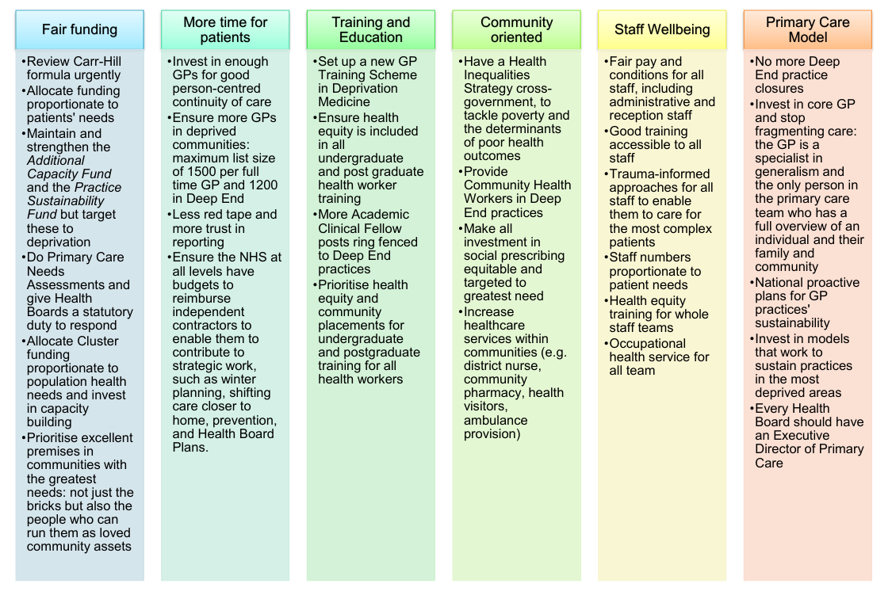
Teg I Bawb – Fair for All
Training for the whole team

Deep End Cymru was invited to collaborate with partners from Public Health Wales and representatives from third sector organisations to create a Welsh version of the Doctors of the World Safe surgeries campaign.
Our deputy chair, Joanna, worked as a practice manager in a socially deprived multi-cultural area of Newport, South Wales and has first-hand experience of the issues facing patients and surgeries in areas of severe and multiple disadvantage.
Joanna said ‘We know that patients in these areas face more challenges before they even enter a primary care setting. They can face stigma and exclusion attached to their social circumstance. This needs to stop. Primary care is here as a first port of call to help keep patients well, to help them to manage their chronic conditions and guide them to help themselves when they are unwell. We are not here to judge’
Joanna was part of the team that created training for our non-clinical workforce to help them better understand the problems of health inequity and social disadvantage and how that shapes a patient and their health needs.
The training aims to challenge the perception of patients and to reduce the bias and misunderstanding that patients can face. The training was piloted during the late spring of 2025 and quantitative analysis showed it was well received by those teams who attended the initial training.
We are delighted to say that in Autumn 2025 Teg I Bawb has been taken on by Health Education and Improvement Wales with a view to it being rolled out as a nationwide training package.
Public Health Wales has adopted the Teg I Bawb name to use on their strategic action plan to address wider health inequality through Primary Care, with Deep End being acknowledged for our contribution in the development of the framework.
Joanna Watts-Jane, Deep End Deputy Chair

If your practice would like to receive the training, please get in touch via Joanna.watts-jane@wales.nhs.uk or DeepEndWales@rcgp.org.uk

Senedd Health and Social Care Committee report on the Future of General Practice

The draft report was tabled for a committee meeting on February 4th, but this has been pushed back and is now scheduled to be discussed at the March 11th meeting. You can watch this and find out more here

Community by Design

This program is being led by the Chief Medical Officer, Dr Isabel Oliver, which is a “Health transformation program to deliver better outcomes through integrated services in the community”. The CbD Board is made up mostly of the Health Board and Trust Chief Executives. They decided to go with 3 Pillars: prevention, chronic conditions management, same day and urgent care. This is the summary so far:

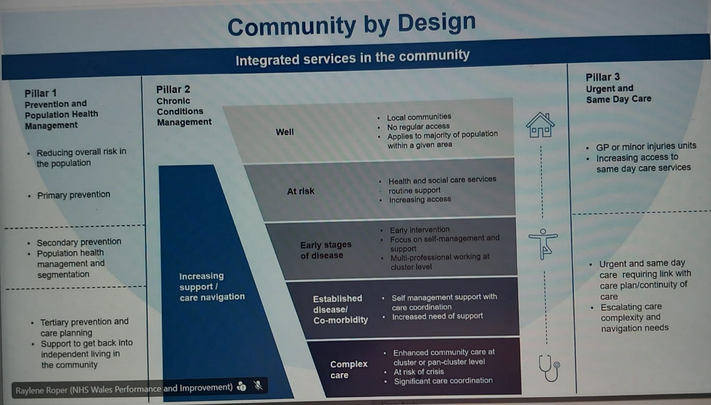

Deep End met with Dr Oliver in January, and she explained the CbD process and invited us to join the Advisory and Reference Group. She also invited Dr Neil James to present at the monthly CbD Board meeting in February. Each Health Board is supposed to set up its own CbD Board too.
The first briefing for the Advisory Group was on February 25th , although cameras, microphones and the chat function were all disabled, so we were unable to ask questions or provide feedback. The presentation was recorded and you can ask for access to this on a SharePoint here .

If you have any questions or any feedback from your local experiences of CbD, please do email us at DeepEndCymru@wales.nhs.uk so that we can collate and bring to the CbD advisory group.

Research update: MoU with PRIME agreed

Deep End Cymru signed a Memorandum of Understanding with the Wales Centre for Primary and Emergency Care Research (PRIME) in January 2026.
Our agreed priorities for collaboration are:
1. Establishing a joint post(s) as the most practical way to deliver our joint objectives in future
2. Establishing a program to engage patients from vulnerable/ underserved populations with participatory and inclusive approaches.
3. Establish an approach to individualised mentorship for Deep End GPs to enable engagement and progression in academic primary care.

You can see more information about our research work, and the MoU here.

Building the Primary Care Workforce: The Recruitment Impact of Student Nurse Placements in Deep End Cymru
As many of you will know, Deep End Cymru have actively engaged with the Practice Nurse Facilitators. These three posts were newly created two years ago and tasked with increasing the number of student nurse placements in community healthcare settings, especially in more deprived communities. They have been very successful in this, so we are very disappointed to hear that HEIW have taken the decision to finish these posts from April, and the task will be moved into other existing roles that deal with all nurse placements (the large majority still in secondary care)
Debbie Roberts, one of the Primary Care Practice Education Facilitators, sent us this summary:
High-quality placements are one of the most powerful tools we have for shaping the future primary care workforce. For pre-registration nursing students, time spent in well-supported general practice settings directly supports national priorities; from the Strategic Programme for Primary Care to the All-Wales General Practice Nurse Foundation Programme. It also aligns with the wider ambition of A Healthier Wales: delivering more care closer to home.
The need has never been clearer. According to a 2025 Royal College of Nursing report, nearly half of nurses working in GP settings are aged 50 or over. With retirement on the horizon for many, the challenge is even sharper in areas of deprivation, including those served by Deep End Cymru practices.
In early 2024, the Primary Care PEF team partnered with Deep End Cymru to expand student nurse placements. Today, 15 Deep End surgeries are hosting students — around 20% of all Welsh practices offering placements. Feedback has been consistently positive, and several students have already moved into General Practice Nursing roles.
One student at Ringland Surgery described the experience as transformative:
“I was privileged to learn and collaborate with knowledgeable and receptive professionals. This placement has sparked my interest in becoming a practice nurse when I qualify. This has been an incredibly amazing experience, and I appreciate every bit of my time with these phenomenal and experienced professionals. Damian, Matthew, Anwen, and every member of the team were fabulous. I am particularly grateful for this invaluable exposure and support.”
These placements also open the door to rich inter-professional learning. Innovative models — such as shared placements between General Practice Nurses and Newport’s Place Based Care Team — give students a rare, immersive view of collaborative, multi-agency care with patients and communities at the centre.
Further information: HEIW.PracticeEducationTeam@wales.nhs.uk
Celebrating excellence across GP nursing placements in Wales - HEIW

Introducing the Health Equity Network for Wales – Join Us!

This network is much wider than healthcare, so there is loads of information that is useful to Deep End that we don’t normally get through our NHS networks.

Wales now has a dedicated space within the UK-wide Health Equity Network (H.E.N.), hosted by the Institute of Health Equity and led by Professor Sir Michael Marmot. This network brings together people and organisations committed to reducing health inequalities and improving wellbeing for all.

The Wales group within H.E.N. offers exactly the kind of functionality we need to begin building a strong, connected community:
- Discussion forums
- Document sharing
- Posting updates and resources
- Running webinars and events
The aim is to use this existing platform to grow a Wales-focused network, bringing together people from multiple sectors and backgrounds, and anyone passionate about advancing health equity across Wales. Depending on momentum, this may eventually evolve into a Wales-hosted platform.

How to Join
- Sign up to the Health Equity Network here: https://healthequitynetwork.co.uk/feed
- Once registered, click on the “Groups” tab.
- Search for Wales and join the group.
Why it matters
Health inequalities remain a major challenge across Wales. By connecting through this network, we can share learning, coordinate efforts, amplify good practice, and build a stronger collective voice for change. Everyone’s perspective is valuable.

ABOUT DEEP END CYMRU
Deep End Cymru Website
www.deependcymru.nhs.wales
www.deependcymru.gig.cymru

Deep End Cymru WhatsApp Group
We have a Deep End WhatsApp Group that is open to anyone working in a Deep End practice, to share information and ask queries.
If you would like to be added, please text/ WhatsApp Dr Kathrin Thomas on 07802 418120 or use this link https://chat.whatsapp.com/D3MVSWY3vX0CMG3dku8jzO


Chair: Dr Neil James
Dr Neil James is a full-time general practitioner working in Meddygfa Cwm Rhymni in the Gwent Valleys. The practice has 18,000 patients in an area of extreme social deprivation. Over the past 20 years he and his GP colleagues have established a practice from a state of vacancy to a new collaborative partnership. The practice has continued to develop by merging with other smaller practices locally in the Rhymney Valley and building sustainability and quality along the way. He is originally from Caerphilly but has worked as a general practitioner overseas and in different parts of the UK. He lives in Brecon with his family.
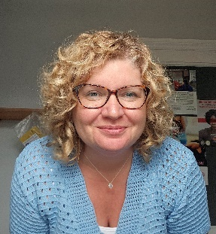
Deputy Chair: Joanna Watts-Jane
Joanna is the Business Manager for the Hirwaun Medical Centre, having recently moved from the Rugby Surgery where she had considerable experience in this inner-city practice with a transient population, homelessness, refugees, language barriers, raised expectations and cultural differences. Joanna states that everyone has needs and that your postcode should not dictate your health, which is something she aims to redress.
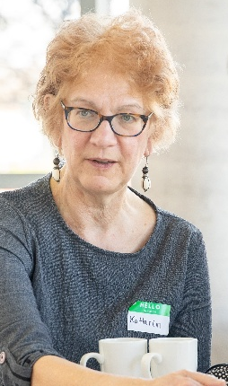
Public Health Lead: Dr Kathrin Thomas
Kathrin has combined careers as a General Practitioner and a Consultant in Public Health. She has focussed on tackling health inequity, both working as a family doctor in the most deprived communities in Liverpool and the South Wales Valleys, and in a variety of public health roles. She is a Bevan Commission Senior Fellow. She was until recently a Co-Chair of the UK Faculty of Public Health Special Interest Group for Primary Care and Public Health and is a member of the Royal College of General Practitioners Health Equity Special Interest Group.

Education and Training Lead: Dr Rebecca Jenkinson
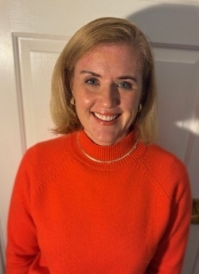
Rebecca is a GP partner at The Kingsway Surgery in Swansea, a Deep End practice serving some of the most deprived communities in the city. She is a GP Programme Director for Swansea Bay with HEIW and Clinical Lead for the Health Inequalities actions within the Workforce Plan for Primary Care. Rebecca also works as a Clinical Lead within the Swansea Bay Practice Support Team, supporting practices to navigate challenges and build sustainability. Born and raised in Swansea, she is committed to improving training, recruitment, and equitable access to high-quality primary care in Deep End areas.


Policy Lead: Dr Jonny Currie
Jonny is a GP partner and clinical lead in Ringland Medical Practice, a GP practice serving a deindustrialised area in the east of Newport close to the old Llanwern steelworks. He is an Honorary Clinical Lecturer at Cardiff University and is also a qualified Public Health Consultant with Cardiff and Vale University Health Board. He is passionate about the use of data, community participation and advocacy to tackle health inequalities.


Coordinator: Bernard Carter
Bernard Carter brings a wealth of experience with a long and successful career in public sector management, in Local Authorities and the NHS.
Bernard works 14 hours a week for Deep End Cymru, mostly on Tuesdays and Thursdays.

Deep End Practices and Clusters
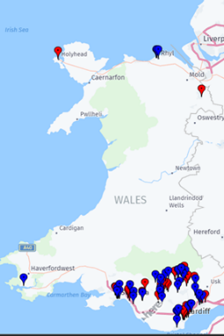
When we began the network in 2022, we identified the 100 GP practices in Wales that had the highest proportion of their patients who lived in the most deprived 20% of LSOAs. All have at least 34% of their patients living in these areas, and some have over 80%. We invited these practices to join Deep End Cymru. Since 2022, 10% of our practices have closed or merged, compared with 2.8% of the other practices in Wales.
Anyone working in these practices, in clinical and non-clinical roles, are eligible to be members of our Steering Group and claim reimbursement for protected time for Deep End activities. In addition, we welcome anyone who shares our goals to come along and join us at all events and meetings and invite us to yours!

Clusters
Most of the Deep End practices are in the Valleys and urban areas. We have identified 17 of the 63 Clusters in Wales who have the same proportion (over 34%) of their patients living in the most deprived communities.
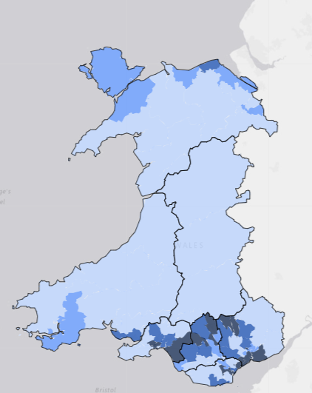
The “Deep End” Clusters include 115 practices, of which 87 are Deep End.
- Blaenau Gwent East
- City & Cardiff South
- Afan
- Penderi
- CityHealth
- Cardiff East
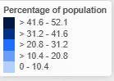
- Cardiff South West
- Newport West
- South Cynon
- Blaenau Gwent West
- Cardiff South East
- Rhondda (combine North a nd South now)
- Bridgend North Network
- Newport East
- Caerphilly North
- Neath
- Torfaen North
Percentage of population resident in most deprived 20% of areas (WIMD), Primary Care Clusters, Wales, 2023 Produced by Public Health Wales using StatsWales (WG)

The support team in the Royal College of General Practitioners Wales are Nicola Edmunds as Head of RCGP Wales, and Amy Clark as Executive Assistant. Both are very part time in their Deep End roles. Dr Rebecca Jenkinson is Training and Education Lead. Dr Kathrin Thomas remains Public Health lead and Dr Harry Ahmed from the Division of Population Medicine at Cardiff University is Academic Lead. For more information about everyone who is involved, please see Deep End Wales Project (rcgp.org.uk), contact us via DeepEndWales@rcgp.org.uk or come to a steering group meeting or a Round Table event!

Welsh Government Support
We have ongoing support from Welsh Government for which we are very grateful, committed until March 2027, if we deliver on an agreed program. The program is based on the grassroots findings from our participants, with four key areas:
- Workforce (developing business cases for what could take the pressure off and improve patient care, and for staff wellbeing and retention/recruitment)
- Education and Training (how we can influence training for health professionals to work in deprived areas)
- Advocacy (Making the Inverse Care Law transparent and advocating to address it)
- Research (what do Deep End patients and staff want to research, improving research engagement by Deep End practices, what impact does Deep End have?)
Practices see value in becoming part of Deep End: we are so much stronger together! We must do this as a network and use the time and energy that we can offer between us. The funding will mostly reimburse the time of participants who attend events and/or do work for Deep End. We have very limited admin and project manager capacity now, so please help in any small ways that you can!
We are delighted to have had contact with 93% of Deep End practices. Our steering group continue to give their time and support freely, for which we are extremely grateful.

Useful resources

- Deep End Cymru webpage Home - Deep End Cymru Hafan - Deep End Cymru CY
- Reducing Health Inequalities through Primary Care - Primary Care One (nhs.wales) Another one of this resource’s useful webpages is Professional development & training​ - Primary Care One (nhs.wales)
- Interested to get more research active in your practice right now? Health and Care Research Wales (HCRW) have agreed a single point of contact for Deep End Cymru practices who wish to find out about becoming more research active. Contact Lewis Darmanin, Research Manager for Health and Social Care. Lewis.Darmanin@wales.nhs.uk
- The Wales Inclusion Health Programme for Primary Care webpage Inclusion health can include any population group at the sharp edge of health inequalities. These groups experience stigmatisation, social exclusion, discrimination and experience “severe, overlapping and multiple disadvantages” across their lives, significantly increasing their risk of poor health. This has also been described as the ‘cliff edge of inequity’. Wales Inclusion Health Programme for Primary Care - Primary Care One (nhs.wales)
- Primary Care Clusters Dashboard Primary Care Clusters Dashboard - Public Health Wales The purpose of the Dashboard is to help understand population health needs and outcomes at the Cluster level to assist with planning and resourcing. They would welcome any feedback: publichealthwalesobservatory@wales.nhs.uk
- Health Equity Evidence Centre: this new academic centre is “A new hub with evidence-informed solutions for equitable health and care” and has a very strong primary care focus. Welcome to the Health Equity Evidence Centre - Health Equity Evidence Centre

If you have any queries, please contact
DeepEndWales@rcgp.org.uk

