Welcome to our latest Deep End newsletter. Please share with all members of your practice team, we are keen to reach everyone working in Deep End practices.



Deep End Wales Newsletter
August 2025

We are recruiting a Deep End Cymru Coordinator
Please share with anyone who may be interested
Part time, 14 hours per week 18-month fixed term contract
Salary band F: £12,748 (£31,870 WTE)
Location: Wales. Flexible working, including elements of home working can be considered. (The office base would be Cardiff)
Closing Date: Midday 1st September 25
Interviews: Tuesday 9th September 25

This is an exciting opportunity for an enthusiastic and forward-looking coordinator with project experience, to administer a recently established Welsh Government funded project.
The successful applicant would be responsible for supporting the development of the ‘Welsh GPs at the Deep End’ project, which is a project to develop a network of GP Practices and their associated primary care teams that work in and with the most deprived communities in Wales, to improve patient outcomes through the support and development of those practices, becoming advocates for the communities as well as for the GPs and their practices.
You should have experience of working in an NHS environment, knowledge of professional organisations and their workings and proven project experience. You will also have excellent communication skills, motivation and drive, as well as a really good understanding of general practice and primary care.
You will need to be a self-starter, able to work flexibly and on your own initiative, with excellent time management and planning skills.
A flexible approach to working hours is necessary as there may be some evening meetings in various locations around Wales.
A flexi-time scheme is in operation.
In return, the College offers excellent terms and conditions.
To find out more, contact DeepEndWales@rcgp.org.uk

Dates for your diary
Steering Group Meetings
The Deep End Cymru steering group is meeting monthly now, with shorter one-hour online meetings. The next ones are Tuesday 2nd September 1pm -2pm, Wednesday 1st October 1pm-2pm, and Thursday November 6th 1pm to 2pm. These are open to anyone working in a Deep End practice. If you are interested to come along, or you wish to add items to the agenda, please email DeepEndWales@rcgp.org.uk

Health Equity Study Day
Wednesday October 22nd Swansea
Venue TBC
We held a successful, well-attended Study Day in March in Newport and are planning to repeat it in Swansea. Topics will include:
- What works to reduce health inequalities through primary care: Primary Care Division, Public Health Wales
- Health Inequalities in Liver Disease: Dr Andrew Yeoman
- Teg I Bawb training for all practice teams
- Nature Prescribing RSPB
- Health Equity in Medical Training
- Childhood vaccinations: hitting targets in the Deep End
- Becoming a research active practice and generating income
- And more to be confirmed…..
If you would like to present something, we would be delighted to hear from you DeepEndWales@rcgp.org.uk or call/WhatsApp Dr Kathrin Thomas on 07802 418 120

Senedd Inquiry into the Future of General Practice in Wales
The Senedd Health and Social Care Committee launched an inquiry into the future of general practice in January 2025. We have submitted written evidence, and several of us have already been invited to focus groups and informal meetings with the Committee Members.
We are now very pleased that Deep End Cymru have been invited to give formal oral evidence at a public hearing of the Committee on Thursday October 23rd 9.30am-11am. You can watch this live via their website
If you wish us to raise any points specifically, please get in touch.
DeepEndWales@rcgp.org.uk
You can find out more here: Inquiry into the future of general practice in Wales

RCGP Annual Conference
Thursday October 9th – Friday October 10th
Deep End Cymru fringe event
Coffee break 10.15-11.15 on Day One
We are delighted that Deep End Cymru has been offered a space for a fringe event at the RCGP Annual Conference in Newport this year. We wanted a formal event together with several other Deep Ends across the UK but this wasn’t to be. If you are going to the conference, please get in touch with us via ThomasK48@cardiff.ac.uk And spread the word to your colleagues and trainees!
Our Session Blurb:
“Deep End Cymru has found the most joyful camaraderie, with many of our GP's and their teams going above and beyond for their communities. We are tired, there is more burnout among our colleagues, greater concern for our patients and ourselves, but still, we persist, and our movement grows stronger. If we don't fight for our patients, who will?
This session will give a taste of the huge variety range of “practical ways” that GP teams can do their part in addressing health inequalities, facilitate discussion and reflection from attendees. And celebrate successes!

NEWS

Deep End GP awarded an MBE
We are delighted that one of Deep End Steering group members, Dr Modupe Obilanade, has been awarded an MBE in the Kings Birthday Honours list in June. Modupe has been a stalwart of Deep End Cymru since its launch.

She has been a partner at St Paul’s Clinic in Newport, leading its transformation into a thriving GP practice serving the whole community.
She is very generous with her time and support, both for her own team and through Deep End for those in other practices, being a great advocate for Deep End Cymru. Her unwavering commitment to improve the health and wellbeing of the most marginalised people in her community is amazing and inspirational.

Great Research Opportunity to get started
This would be a good way to take a first step on the research journey for your practice, while generating some income.
The Cardiff University study team invite you to participate in the ESTEEM trial, a clinical trial conducted in a primary care setting. The study team are aiming to recruit via a central model where patients can self-refer in, as well as including roughly 5 GP practices as recruiting sites. Please note the study team are particularly keen to include practices covering areas of high deprivation and/or ethnic minority groups.
The ESTEEM trial aims to determine if adding testosterone to standard Hormone Replacement Therapy (HRT) can alleviate menopausal symptoms beyond its effects on sexual function (libido). This trial will be the first to establish the impact of testosterone on menopause-related symptoms other than sexual function, such as cognitive issues (including "brain fog" and difficulty concentrating), hot flashes, night sweats, exercise, motivation, and energy levels in menopausal women. Additional benefits for women may include improved mood and increased focus in the workplace.
The trial is a randomized controlled trial (RCT) led by the Centre for Trials Research at Cardiff University, and funded by the National Institute for Health and Care Research (NIHR), with support from Health and Care Research Wales and the NIHR Clinical Research Network. Over 400 menopausal women will have the opportunity to self-refer to the trial or enrol through their GP practices.
We aim to begin recruitment in Sept 2025. Participating general practices will receive financial remuneration of £1,245 upon opening to recruitment, which includes a £400 set-up fee. Additionally, sites will earn £100 for each participant recruited, £100 for conducting screening visits, and £30 for each participant's randomization.
If you are interested in joining the trial as a participating site, please kindly complete the expression of interest form before August 22nd:
https://app.onlinesurveys.jisc.ac.uk/s/cardiff/esteem-expression-of-interest-questionnaire
Thank you for considering this opportunity. We know it is a very busy time for GP practices, and we really appreciate your support. If you would like any further information, please feel free to contact me: Martina Svobodova, Research Associate/Trial Manager, Centre for Trials Research (CTR), esteem@cardiff.ac.uk”

Deep End Cymru Manifesto

We have worked in our Deep End Cymru manifesto for several months, and it has had input from many people, through our Round Tables, steering group meeting discussions and surveys. We shared a final draft with you on 24th July by email and its now ready (see here). We aim to launch this at the Senedd in September, in the lead up to the Senedd elections in May 2026. We will take the messages in it to each party and advocate for it wherever we can.
If you would like to help, for example by inviting your local AM/MS to visit your practice and use the Manifesto for discussions with them, please go for it and let us know.
This is our chance to demonstrate the strength of our passion, voice and commitment
Jonny Currie, Owain James
Key messages:
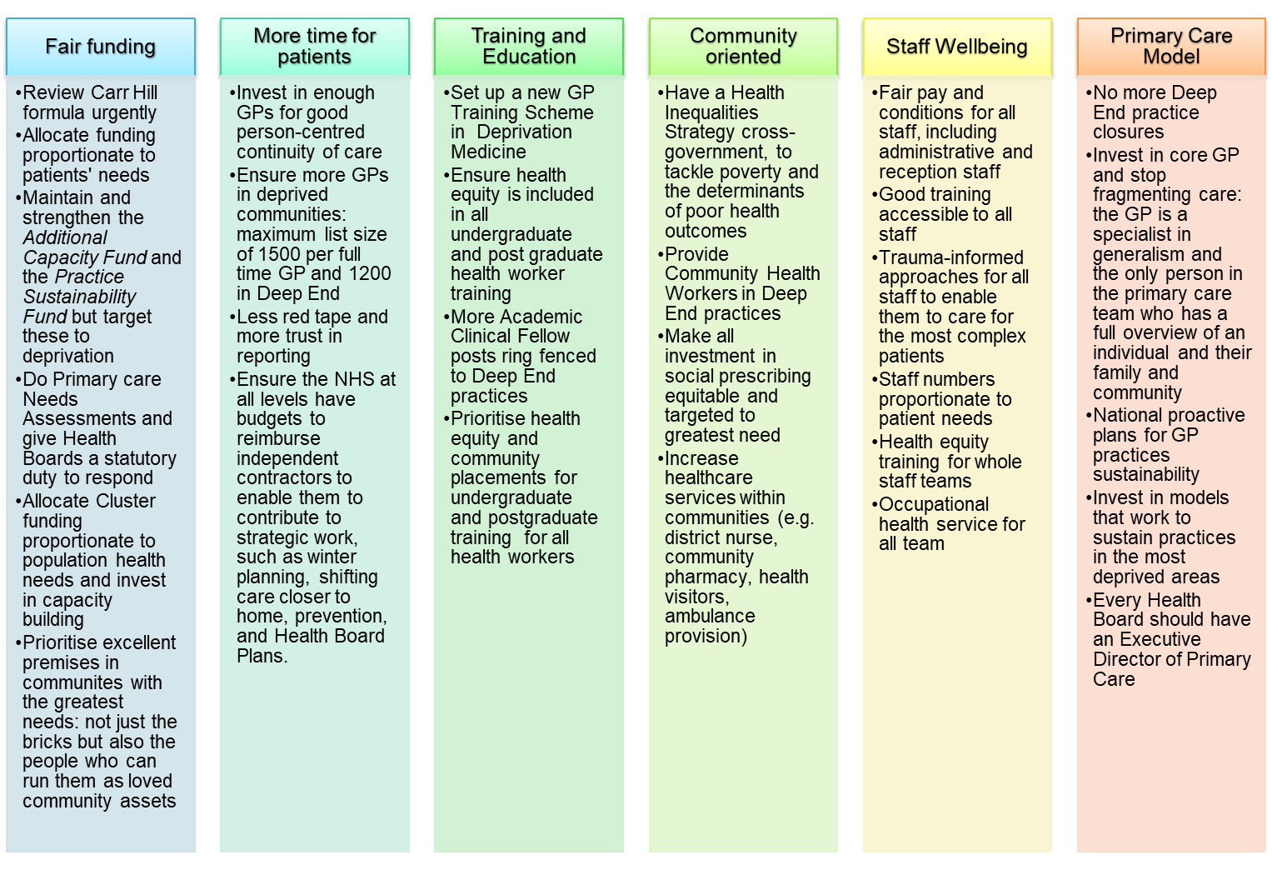

Teg I Bawb – Fair for All
Training for the whole team
Deep End, alongside colleagues from PHW and other agencies, has created a free simple training package that aims to make general practice more inclusive and accessible to all patients. This is especially when they first wish to register and shows how to reduce stress for patients and staff.
It was started in response to the “Safe Surgeries Toolkit” from MSF and adapted for the Welsh context.
The training has been trialled in several practices, with excellent feedback from teams, so it is now being rolled out to all GP Practices in Wales.
It is primarily aimed at our front of house teams who often get the short end of the training stick with courses supplied by the LHB’s that aren’t really designed for them. The training session engages our teams and gets them thinking about what sits behind a patient when they present to us and challenges their thinking and preconceptions. All attendees will have a handout pack to refer back to. Training lasts about 45 minutes and can be delivered online if you feel that is easier.
This training sits nicely alongside the RCGP Fairer Practice Toolkit due to be launched in October.

I hope this gives you an insight into Teg I Bawb, which is all about making general practice fair for all.
Joanna Watts-Jane, Deep End Deputy Chair
If your practice would like to receive the training, please get in touch via Joanna.watts-jane@wales.nhs.uk or DeepEndWales@rcgp.org.uk

GMS QI Project for Continuity of Care
We have identified continuity of care as a priority for our patients, as it has major benefits for more complex patients. However, continuity is harder to provide when resources are tight in Deep End practices. So, we welcome the new QI project in the GMS contract but are keen that it is implemented to benefit Deep End patients and not disadvantage Deep End practices even further.
The current GMS contract includes a 5-year Quality Improvement Project to improve continuity of care, based on the RCGP Continuity of Care Toolkit, with a review by the GMS Quality Committee in the 3rd year to establish whether it continues into years 4 and 5.
A Continuity of Care QI Project Working Group has been set up, which includes representatives from the Welsh Government, GPC Wales, NHS Wales and other key stakeholders, to organise and plan for the resources needed for the QI project this year (2025-26) and in subsequent years.
Deep End Cymru have been asked to join this Group
Anyone who is interested, please contact DeepEndWales@rcgp.org.uk

Practice Staff Wellbeing
We have started considering staff wellbeing with the help of Dr Karen Sankey. She is developing a brief educational resource: Introduction to Self-Care for Frontline Staff and Clinicians as a first step, and then we will be working on co-producing a Team Wellbeing Plan that practices can adapt to their circumstances.
Karen reports that ““The impact of stress on Deep End practice staff, including its effects on sickness, retention, and patient care, cannot be overstated. Research suggests that working in the NHS is more stressful than any other job sector in the UK. As much as 90% of human illnesses, mental and physical, have their origin in exposure to stress. Compounding this, staff working in areas of high socioeconomic deprivation have an increased risk of burnout than their peers working in more affluent areas, creating challenges with recruitment and retention of a healthy workforce.
Prioritising individual and team wellbeing can feel like a luxury, pushed down the to-do list by the ‘tyranny of the urgent’. It is exactly this dilemma that contributes to the downward cycle: ongoing stress, lack of space to care for ourselves and each other, and rising risk of burnout”.
We will be looking for a small number of practices, especially practice managers, to work with us on this.
If you are interested, please contact Joanna Watts-Jane on joanna.watts-jane@wales.nhs.uk and DeepEndWales@rcgp.org.uk

Liver Disease in Wales: In at the Deep End
Liver disease is on the rise and Wales has seen an almost quadrupling in the incidence of cirrhosis over the last 20 years. This increase is predominantly driven by excess alcohol consumption and fatty liver disease driven by weight gain/obesity.
It will therefore not surprise anyone that works in disadvantaged communities that liver disease is very much a disease of deprivation. This relationship isn’t just in relation to incidence, but also severity. Data shows that there is a five-fold variation in mortality rates between the worst and least affected local authority areas in England. Furthermore, patients with liver disease in the most deprived quintile will die almost a decade younger than those in the least.
Whilst many of the drivers of this phenomenon may be beyond us as health care professionals, that is not to say clinicians have no role in addressing these health inequalities.
For example, assertive care pathways that assist in identifying patients with advanced liver disease are feasible and effective. Education of the public and other specialties and development of multi-disciplinary networks can also facilitate early detection while advocacy for marginalised groups can help reduce stigma. Finally, secondary care needs to do better at providing accessible diagnostics and interventions (place-based care) to minimise the impact of the “Inverse Care Law”.
In that respect we would be very interested in speaking with anyone involved in Deep End Cymru who may have suggestions on how we can tackle this particular challenge.
Dr Andrew Yeoman, Hepatologist in Newport, Gwent

Dr Yeoman established the Gwent Liver Unit in 2013 along with Dr Czajkowski. In 2014 he helped draft the Wales Liver Plan which was launched in 2015 and has been the clinical lead for the programme ever since.
He spoke at our Health Equity Study Day in March this year, and will be speaking again at the next Health Equity Study Day on October 22nd in Swansea

COMMUNICATIONS
Deep End Cymru Website
We are finally live!!
www.deependcymru.nhs.wales
www.deependcymru.gig.cymru

Deep End Cymru WhatsApp Group
We have a Deep End WhatsApp Group that is open to anyone working in a Deep End practice, to share information and ask queries.
If you would like to be added, please text/ WhatsApp Dr Kathrin Thomas on 07802 418120 or use this link https://chat.whatsapp.com/D3MVSWY3vX0CMG3dku8jzO

About Deep End Cymru

Chair: Dr Neil James
Dr Neil James is a full-time general practitioner working in Meddygfa Cwm Rhymni in the Gwent Valleys. The practice has 18,000 patients in an area of extreme social deprivation. Over the past 20 years he and his GP colleagues have established a practice from a state of vacancy to a new collaborative partnership. The practice has continued to develop by merging with other smaller practices locally in the Rhymney Valley and building sustainability and quality along the way. He is originally from Caerphilly but has worked as a general practitioner overseas and in different parts of the UK. He lives in Brecon with his family.
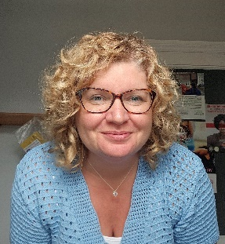
Deputy Chair: Joanna Watts-Jane
Joanna is the Business Manager for the Hirwaun Medical Centre, having recently moved from the Rugby Surgery where she had considerable experience in this inner-city practice with a transient population, homelessness, refugees, language barriers, raised expectations and cultural differences. Joanna states that everyone has needs and that your postcode should not dictate your health, which is something she aims to redress.
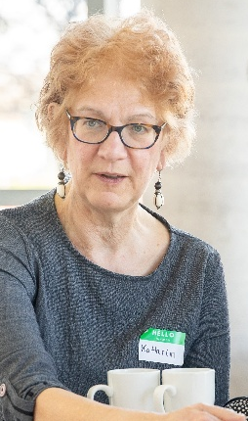
Public Health Lead: Dr Kathrin Thomas
Kathrin has combined careers as a General Practitioner and a Consultant in Public Health. She has focussed on tackling health inequity, both working as a family doctor in the most deprived communities in Liverpool and the South Wales Valleys, and in a variety of public health roles. She is a Bevan Commission Senior Fellow. She was until recently a Co-Chair of the UK Faculty of Public Health Special Interest Group for Primary Care and Public Health and is a member of the Royal College of General Practitioners Health Equity Special Interest Group.

Deep End Practices and Clusters
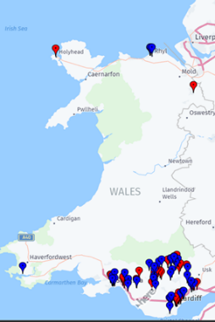
When we began the network in 2022, we identified the 100 GP practices in Wales that had the highest proportion of their patients who lived in the most deprived 20% of LSOAs. All have at least 34% of their patients living in these areas, and some have over 80%. We invited these practices to join Deep End Cymru. Since 2022, 10% of our practices have closed or merged, compared with 2.8% of the other practices in Wales.
Anyone working in these practices, in clinical and non-clinical roles, are eligible to be members of our Steering Group and claim reimbursement for protected time for Deep End activities. In addition, we welcome anyone who shares our goals to come along and join us at all events and meetings and invite us to yours!

Clusters
Most of the Deep End practices are in the Valleys and urban areas. We have identified 17 of the 63 Clusters in Wales who have the same proportion (over 34%) of their patients living in the most deprived communities.
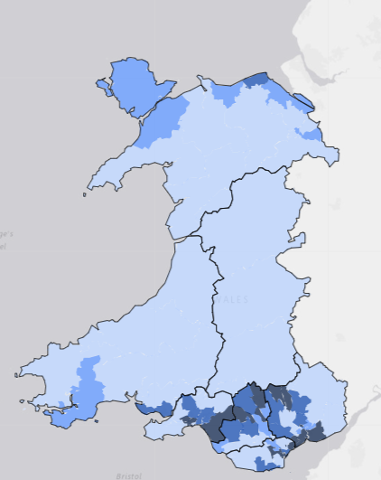
The “Deep End” Clusters include 115 practices, of which 87 are Deep End.
- Blaenau Gwent East
- City & Cardiff South
- Afan
- Penderi
- CityHealth
- Cardiff East
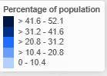
- Cardiff South West
- Newport West
- South Cynon
- Blaenau Gwent West
- Cardiff South East
- Rhondda (combine North a nd South now)
- Bridgend North Network
- Newport East
- Caerphilly North
- Neath
- Torfaen North
Percentage of population resident in most deprived 20% of areas (WIMD), Primary Care Clusters, Wales, 2023 Produced by Public Health Wales using StatsWales (WG)

The support team in the Royal College of General Practitioners Wales are Nicola Edmunds as Head of RCGP Wales, and Amy Clark as Executive Assistant. Both are very part time in their Deep End roles. Dr Rebecca Jenkinson is Training and Education Lead. Dr Kathrin Thomas remains Public Health lead and Dr Harry Ahmed from the Division of Population Medicine at Cardiff University is Academic Lead. For more information about everyone who is involved, please see Deep End Wales Project (rcgp.org.uk), contact us via DeepEndWales@rcgp.org.uk or come to a steering group meeting or a Round Table event!
Welsh Government Support
We have ongoing support from Welsh Government for which we are very grateful, committed until March 2027, if we deliver on an agreed program. The program is based on the grassroots findings from our participants, with four key areas:
- Workforce (developing business cases for what could take the pressure off and improve patient care, and for staff wellbeing and retention/recruitment)
- Education and Training (how we can influence training for health professionals to work in deprived areas)
- Advocacy (Making the Inverse Care Law transparent and advocating to address it)
- Research (what do Deep End patients and staff want to research, improving research engagement by Deep End practices, what impact does Deep End have?)
Practices see value in becoming part of Deep End: we are so much stronger together! We must do this as a network and use the time and energy that we can offer between us. The funding will mostly reimburse the time of participants who attend events and/or do work for Deep End. We have very limited admin and project manager capacity now, so please help in any small ways that you can!
We are delighted to have had contact with 93% of Deep End practices. Our steering group continue to give their time and support freely, for which we are extremely grateful.

Useful resources

- Deep End Cymru webpage Home - Deep End Cymru Hafan - Deep End Cymru CY
- Reducing Health Inequalities through Primary Care - Primary Care One (nhs.wales) Another one of this resource’s useful webpages is Professional development & training​ - Primary Care One (nhs.wales)
- Interested to get more research active in your practice right now? Health and Care Research Wales (HCRW) have agreed a single point of contact for Deep End Cymru practices who wish to find out about becoming more research active. Contact Lewis Darmanin, Research Manager for Health and Social Care. Lewis.Darmanin@wales.nhs.uk
- The Wales Inclusion Health Programme for Primary Care webpage Inclusion health can include any population group at the sharp edge of health inequalities. These groups experience stigmatisation, social exclusion, discrimination and experience “severe, overlapping and multiple disadvantages” across their lives, significantly increasing their risk of poor health. This has also been described as the ‘cliff edge of inequity’. Wales Inclusion Health Programme for Primary Care - Primary Care One (nhs.wales)
- Primary Care Clusters Dashboard Primary Care Clusters Dashboard - Public Health Wales The purpose of the Dashboard is to help understand population health needs and outcomes at the Cluster level to assist with planning and resourcing. They would welcome any feedback: publichealthwalesobservatory@wales.nhs.uk
- Health Equity Evidence Centre: this new academic centre is “A new hub with evidence-informed solutions for equitable health and care” and has a very strong primary care focus. Welcome to the Health Equity Evidence Centre - Health Equity Evidence Centre

If you have any queries, please contact
DeepEndWales@rcgp.org.uk

