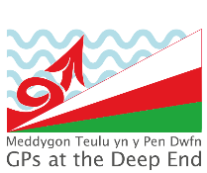
Welsh GPs at the Deep End Project
Round Table Event:
Prevention & Early Intervention
Wednesday 23rd September
1pm – 5pm Bryngarw House, Brynmenyn, Bridgend, CF32 8UU

Event Programme
13.00 - 13.30 | Registration and Lunch
13.30 – 13:40 | Welcome and Introduction | Dr Jonny Currie
13:40 – 14:00 | Making the shift to prevention | Marie Brousseau-Navarro (Deputy Future Generation Commissioner & Director for Health)
14:00 – 14:30 | What are we doing now? What is different about Deep End practices/ Clusters?  • Challenges  • opportunities | Poll, participation/ discussion
14.30 – 15.10 | World Café of prevention/ early intervention programs
15.10– 15.30 | Break and refreshments
15.30 -15:50 | Prevention & Early Intervention in Primary Care – setting the scene | Expert Speaker 2
15:50-16.30 | What could we do more of/less of/ do differently?  - National  - Health Board  - Cluster  - Practices | Everyone
16:30 – 16:45 | Deep End Cymru update | Jo Watts Jane
16.45 – 17.00 | Closing Remarks | Dr Jonny Currie
Evaluation and Close
Delegates are requested to complete evaluation forms

