
Welsh GPs at the Deep End Project
Round Table Event: Digital and technology in the Deep End
Wednesday December 3rd, 2025

Summary
This was the 8th in our Deep End Cymru series of Round Table deep dives into a topic that our practices believe is important. We focus on solutions, so as well as clarifying the challenges, we come up with ideas for ourselves and others to solve those challenges. This time, we explored the hot topic of the impact of digital and technology in general practice, and what’s different and special to Deep End practices and patients. There were 42 participants many of whom were GPs in Deep End practices together with Practice Managers, other support staff and a number of medical students.

Key Challenges in Deep End practices:
- Digital inequality: Technology risks widening health inequalities rather than reducing them, particularly affecting patients with disabilities, learning difficulties, language barriers, and those experiencing data poverty
- Access: Vulnerable groups (those in hostels, without phones or internet access) are being left behind by digital-first approaches
- Workload concerns: Uncertainty about managing new systems, balancing access with continuity of care, and lack of time to explore digital opportunities
- Legal and governance gaps: Uncertainty about the legality of using AI in practice, and GPs feeling unable to be data governance experts without clear guidance
Key Opportunities
Despite challenges, participants saw significant potential benefits from digital technology:
- Time and efficiency gains: AI tools could save time during consultations and free up clinical capacity through assistance with administrative tasks like support letters and reports. Practice efficiencies through tools like total triage, web forms, and the MySurgery app could streamline workflows
- Supporting vulnerable and marginalized patients: Technology could actively reduce barriers for disadvantaged groups through translation software and language support, improved health education to help patients take control of their conditions, and support for those with communication difficulties or learning disabilities during consultations
- Improved access models: Digital solutions for digitally capable patients could free up face-to-face appointment slots for those who are digitally excluded or prefer in-person care. Virtual reception and AI triage systems could improve care navigation, while tools like eConsult could help manage certain conditions more efficiently
- Better clinical care: Technology could enable improved understanding of patient conditions through remote monitoring (such as ChatGP for home blood pressure readings), support medication reviews and allow remote condition management where appropriate
- System-level improvements: Centralized, funded systems could deliver economies of scale across Wales. NHS App improvements and better integration with clinical systems like EMIS could create more cohesive digital infrastructure. The EMIS community and practice websites with patient email were seen as valuable existing tools
Priority Actions. Participants called for:
- Equity-focused approach
- Better funding and support
- Clear guidance
- Practical solutions
For Welsh Government:
- Adopt the current English clinical safety legislation and make mandatory in Wales
- Develop and produce a Welsh digital health and care inclusion and prevention strategy
- Legislate digital safety framework
- Reconsider the funding of UPCC and redirecting to general practice
- More funding into primary care (and to recognise the unique challenges in Deep End practices)
- More engagement with general practice
- Additional IT support for Deep End practices
For DHCW
- Enable Resource Publisher
- Allow EMIS to be used in Wales
- Enable Primary Care IT (Ardens?)
- Publicise AI possibilities and how to best use
- Allow data sharing across platforms e.g. EMIS & PaRIS
- Tailored approach (job specific, demographic specific, targeted)
- Communicate better with managers
- NHS Wales App – support on how it integrates with clinical systems
- Brochure of approved systems
- Better support with digital solutions
- Uniform system
- More GPs to work with DHCW
- Any centralising of systems needs greater piloting and full Practice Manager involvement
- Develop a menu of digital options
Health Boards
- Funding support centralised to give equity across health board
- Make QIPs something that are agreed with clinicians
- Invest in rolling out enhanced services
- AI implementation at a health board level
- EMIS – bespoke to Wales not an extension to England
- Ensure the workload given from secondary care is adequately funded
Clusters
- IT expert/digital lead for each cluster
- Language hub
GP Practices
- Time for training
- Robotic process automation
Deep End Project
- Portal for sharing of success stories/good ideas/tools/policies, etc
- Invite & involve nurses, pharmacists, reception & admin staff to Deep End meetings
- Baseline skills training for staff
- Identify additional funding to support digital training, health literacy and development of patient participation groups
(summary generated by AI, and then adapted)

Report

1 | Welcome and Introduction
 | Dr Neil James welcomed attendees to the event, briefly explained what Deep End Wales was all about and asked attendees what they wanted to get out of this afternoon's session regarding digital and technology issues within Deep End practices (using a Mentimeter interactive presentation). The results of the Mentimeter question were displayed at the event via a word cloud (copied below).
 | 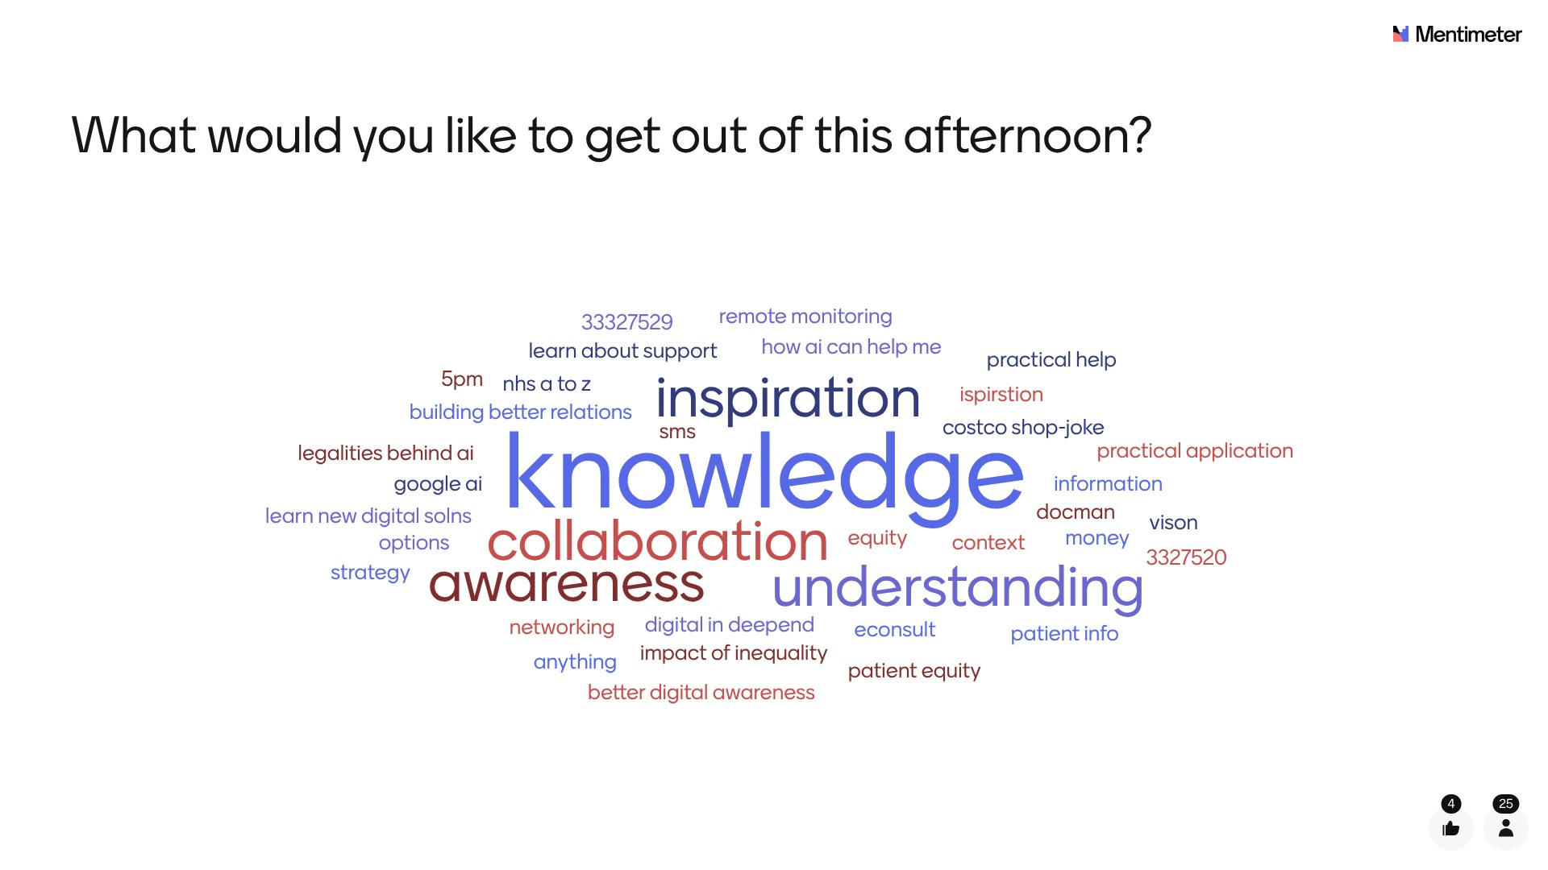
2 | Movement and Health Taster
 | Dr Thania Acaron led an engaging and interactive session covering dance movement psychotherapy, which was well received by attendees. The accompanying PowerPoint presentation is embedded below.
3 | What do we mean by digital and technology?
 | Joanna Watts-Jane led a session, which outlined current clinical systems and how they are used. She also outlined what Practices should consider before any new system is implemented and ended the session by covering the advantages and disadvantages of AI. The accompanying PowerPoint presentation is embedded below.
4 | What’s going on? What are the challenges and opportunities?
 | Dr Kathrin Thomas led this session, which attempted to identify the Information Technology (IT) challenges faced by practices (particularly in the Deep End) and as a counterbalance to this, to also identify the opportunities IT offered practices.
 | The session included a brainstorming exercise using flip charts and post it notes where attendees were asked to ascertain the challenges and opportunities in small groups of 8 to 10 people. The output from these groups is captured below.
 | Challenges | Opportunities
 | - Uncertainty of legality of using AI in Practice  - Making digital equitable (not increasing inequalities)  - NHS App inflexibility  - Workload Management  - Abuse of system by small numbers of people  - Disabilities (learning difficulties, memory loss, visual impairment)  - Balancing access v continuity of care  - Some older GPs don't like technology  - Lack of patient skills to use technology  - Language barriers  - Training  - Data poverty  - Poor health literacy  - Typing notes allows time to process, AI may not  - Security of Data  - Loss of admin staff roles  - AI tools v clinical judgement  - Lack of humanity  - Poor engagement with social media  - Locums using AI without Practice's knowledge  - Cost prohibitive  - Digital hinders forming relationships  - Getting patients to use the system correctly  - Trust issues  - Reliability of IT systems  - Lack of time to investigate digital opportunities  - Patients accessing results  - Resistance to change | - Frees up time  - NHS App improvements  - Opportunities to support consultations for those with barriers (poverty, communication skills, learning disabilities, etc)  - Practice efficiencies  - Improved understanding of patient condition  - Help improve education so patients take control of their illness  - Help with language barriers/translation software  - My surgery app, total triage  - AI Assist  - Could save time with consultations  - Better care navigation  - Use of ChatGP for home BP readings  - Use of AI for support letters & reports  - DHCW should develop a system for Wales  - Advanced bookings  - Opportunity to manage conditions remotely  - Webforms on website  - Digital solutions for digitally savvy patients could improve the time available for face to face access to those who are digitally excluded  - Econsult could help with certain conditions  - Centralised, funded systems will deliver economies of scale  - Virtual reception/AI triage  - EMIS community  - Practice website/patient email useful
 | Finally, there was an opportunity for attendees to highlight personal gripes currently being experienced in the digital and technology realm and these are highlighted below.
- Lack of support from specialists (DHCW)
- Practices need help to understand what is available
- Econsult - limit its use for admin purposes (sick notes)
- WIS
- Lack of wifi/data, lack of phones
- Why does Wales have to do 'once for Wales' when off the shelf solutions are available and working elsewhere?
- UPCC, get rid, bring money back into general practice
- Patients in hostels (and other vulnerable and marginalised groups) do not have access to phones
- GPs cannot be expected to be experts in data governance - there needs to be clear guidance from WG/DHCW
5 | DHCW
 | Dr Sayma Ahmed led the next session, which outlined DHCW's role in shaping primary care within NHS Wales. She explained the role of a clinical informaticist and introduced attendees to the General Practice Discovery. Finally, she opened a discussion with attendees to understand the key challenges facing practices in the Deep End and the opportunities for collaboration with the DHCW. The accompanying PowerPoint presentation is embedded below.
6 | Good Ideas
 | Dr Neil James led a short session, which encouraged attendees to identify any bright ideas or solutions within digital and technology that they are currently aware of, using or could access in the future. Attendees were split into six groups, and the resulting output is detailed below.
Table 1

- iGPR, mental health related
Table 2

- Current health literacy barriers, basics of self-care, children’s education, any mechanism to deliver digital services
Table 3

- Formalise shared learning space (Café PM for Practice Managers)
- Medication review (possible national solution)
- What could AI do for each job role in general practice
Table 4

- Get used to the basics
- Shared network for best practice
- Evaluate whole system processes, not just what’s best for me
Table 5

- AI in different languages
Table 6

- Need a better solution for language barrier issues
 | Finally, Dr James used another Mentimeter interactive presentation to ask attendees what one change would make the biggest difference to Deep End practices. The results of the Mentimeter question were displayed at the event and is copied below for information.
 | 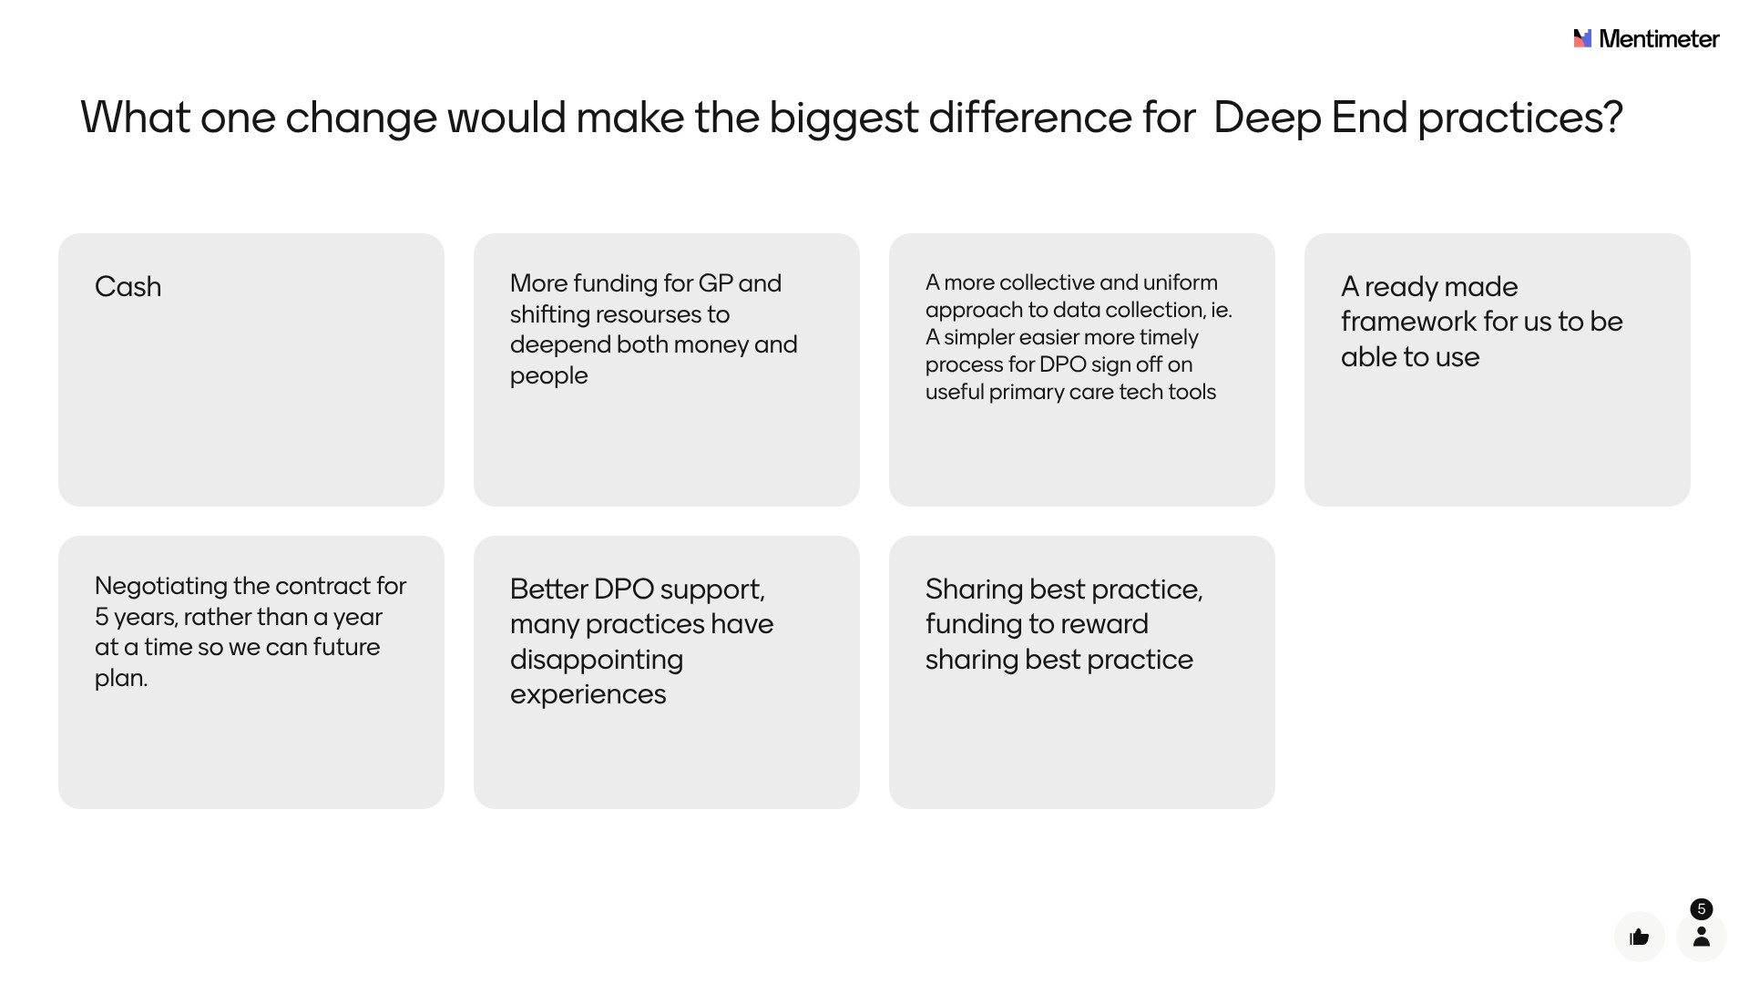
7 | Actions
 | Dr Kathrin Thomas led another brainstorming session using post it notes and flip charts where she asked attendees to again split into small groups to discuss what actions they felt various stakeholders should be doing to improve the digital and technology offer to practices in the Deep End. The various stakeholders included practices, clusters, health boards, DHCW, Welsh Government and the Deep End project itself. The output from these groups is captured below.
 | Welsh Government
- Adopt the current English clinical safety legislation and make mandatory in Wales
- Develop and produce a Welsh digital health and care inclusion and prevention strategy
- Legislate digital safety framework
- Reconsider the funding UPCC and redirecting to general practice
- More funding into primary care (and to recognise the unique challenges in Deep End practices)
- More engagement with general practice
- Additional IT support for Deep End practices
 | DHCW
- Enable Resource Publisher
- Allow EMIS to be used in Wales
- Enable Primary Care IT (Ardens?)
- Publicise AI possibilities and how to best use
- Allow data sharing across platforms e.g. EMIS & PaRIS
- Tailored approach (job specific, demographic specific, targeted)
- Communicate better with managers
- NHS Wales App – support on how it integrates with clinical systems
- Brochure of approved systems
- Better support with digital solutions
- Uniform system
- More GPs to work with DHCW
- Any centralising of systems needs greater piloting and full Practice Manager involvement
- Develop a menu of digital options
 | Health Boards
- Funding support centralised to give equity across health board
- Make QIPs something that are agreed with clinicians
- Invest in rolling out enhanced services
- AI implementation at a health board level
- EMIS – bespoke to Wales not an extension to England
- Ensure the workload given from secondary care is adequately funded
 | Clusters
- IT expert/digital lead for each cluster
- Language hub
 | GP Practices
- Time for training
- Robotic process automation
 | Deep End Project
- Portal for sharing of success stories/good ideas/tools/policies, etc
- Invite & involve nurses, pharmacists, reception & admin staff to Deep End meetings
- Baseline skills training for staff
- Identify additional funding to support digital training, health literacy and development of patient participation groups
8 | Update from Deep End Cymru and Closing Remarks
 | Dr Neil James concluded the session with an update on current activities within the Deep End project and referred all to the latest newsletter circulated by email and published on the Deep End website. Using a further Mentimeter interactive presentation he then asked all attendees whether they felt they had got what they wanted from today's event. The result of the Mentimeter question was displayed at the event and is copied below for information. This feedback will be used to improve future events and attendees were also invited to submit any additional feedback to the Deep End Wales email address at deependwales@rcgp.org.uk
 | 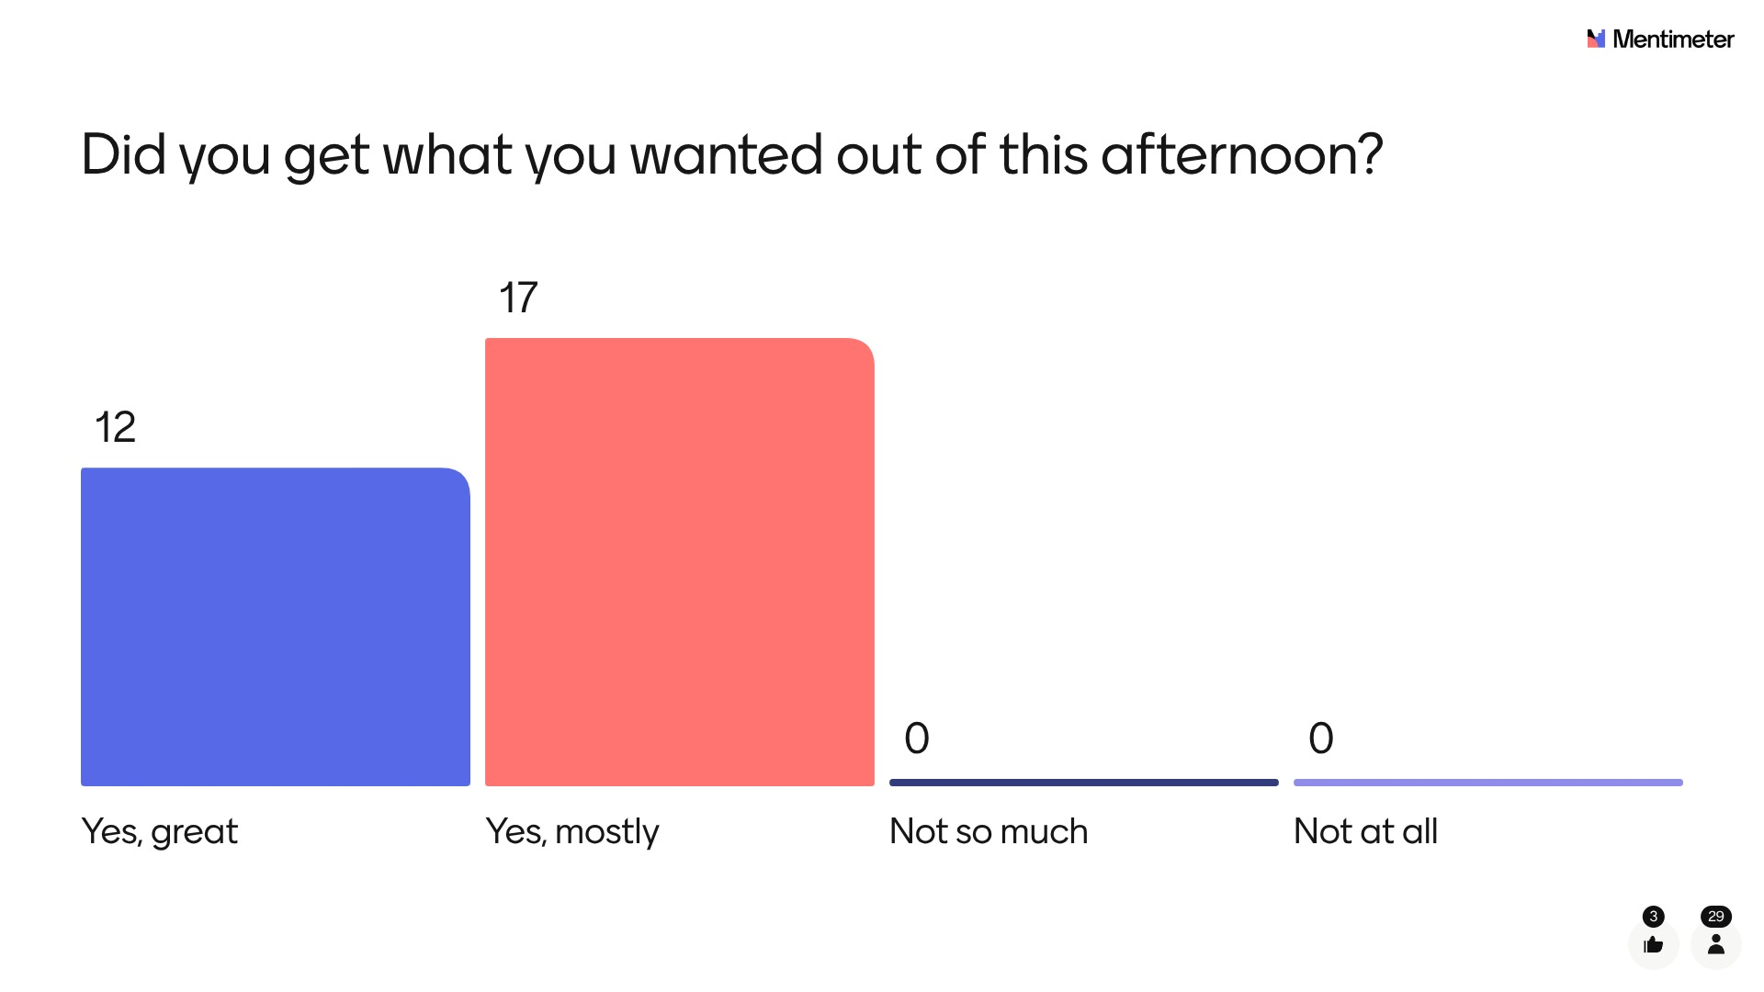
 | Finally, Dr James confirmed that the information gathered today would be used by the Deep End core team as supporting evidence when advocating for better recognition and acknowledgement of the unique and difficult challenges facing Deep End practices, and better, more equitable, funding as a result.

