

Round Table 19.05.26 – Cluster Priorities in High Need Areas

Introduction
The theme this time was how Deep End Cymru can work with the Cluster infrastructure and what might be the mutual priorities.
Deep End Cymru has identified 20 of the 60 Clusters in Wales as Deep End Clusters, because they have >35% of their patients living in the most deprived communities, and/or have a majority of their GP practices who are Deep End and have very large pockets of deprivation, see table and map below.
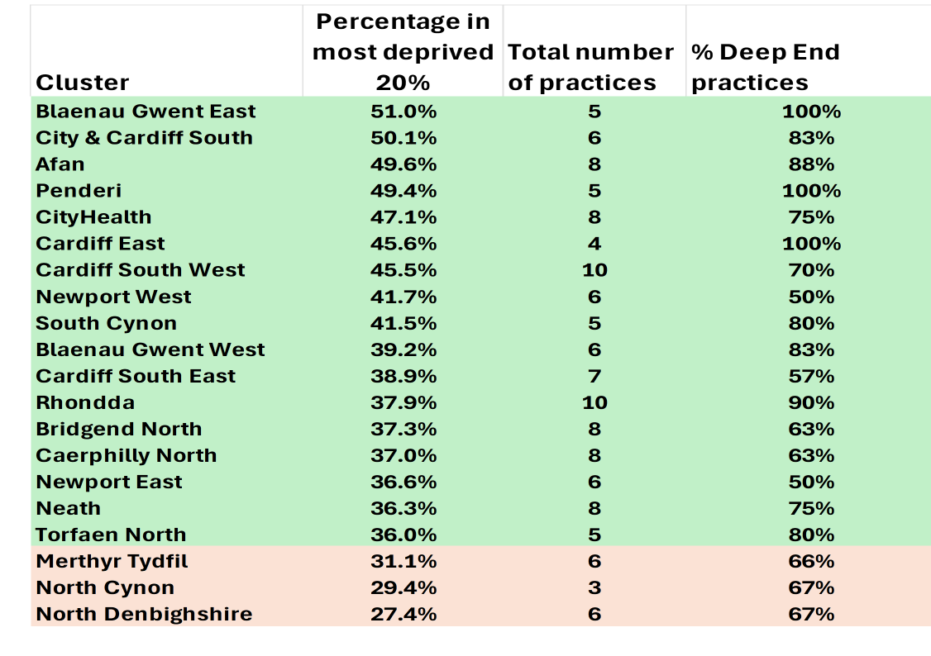
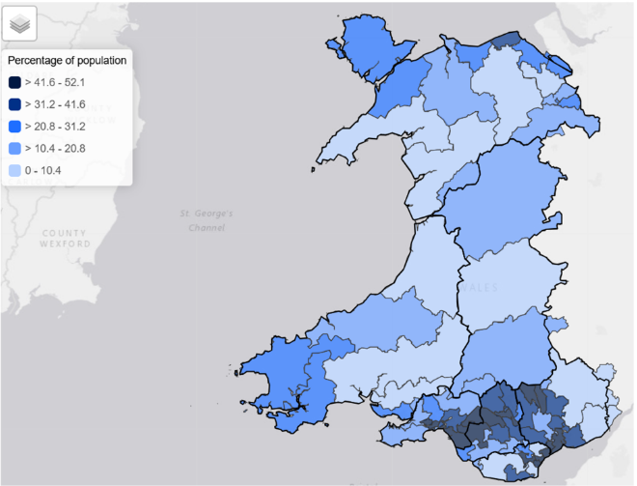

Session 1: How do Deep End Clusters differ?
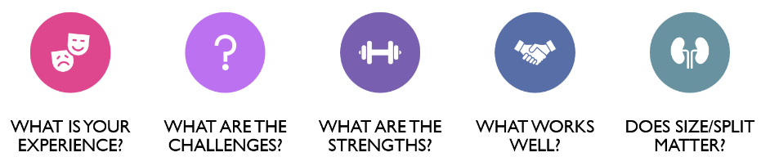
- Everyone agreed that it would be useful to have a “Deep End Cluster” brand and identity
- “Inequalities are manmade”
- No one “up there” has any idea what Clusters are, or what they are doing
- Variability across Clusters is huge, for multiple reasons, not enough standardisation of projects but also a fear that standardisation will take away local decision-making
- Some strengths and successes e.g. First contact physio, Pharmacists (initially)
- Concerns that there are inequities in funding and headspace, so Deep End Clusters more likely to lose out
- Short term planning – 12 months project funding but can take that long just to set up. Slippage goes back into HB so they have incentive to turn down project ideas
- Need to have better data and better analysis
  - Don’t have detailed granular data on population so cannot do PHM,
  - Data sharing is big barrier and must be sorted, currently asking each practice to run same searches and share results with data sharing agreements
- Many programs are one size for all, but don’t work for our patients e.g.
  - Mental health 111 press 2 – reluctance among many, esp. ethnic monitories, language barriers
  - Common Ailments scheme – no account for longer consultations for more complex/ second language patients

Session 2: Developing a Deep End Cymru Cluster Position Statement
As a whole group, we discussed how can we build on the current Cluster place-based infrastructure to better tackle health inequalities? Below are the suggested proposals on what content could feature in a position statement from Deep End Cymru of how primary care clusters in Wales could more meaningfully tackle health inequalities. Suggested additions or edits from the Deep End Cymru team have been added in italics.
Government
- Ensure more information sharing nationally on what projects have been approved between regions and health boards, with a focus on health inequalities and deprivation, such as databases, forums and other information exchange systems
- Commit to dedicated inequalities funding given proportionally to primary care clusters
- Ensure cluster funding is ring-fenced and does not contribute to financial bottom-line of health boards if unspent, considering a proportion rolling funding over to following year
- Ensure avoidance of penalties or lost revenue for services in Deep End areas if targets for performance are not met, including potential for differential targets
- Clear long-term strategic planning with long-term resourcing particularly supporting action on inequalities
- Funding to support communities among whom English is not a first language and other groups with specific language or sensory needs, including potential technological solutions
- More appropriate funding to enhanced services focussed on Deep End community needs
Health Boards
- More supportive approach for new projects even if such initiatives could lend support to GMS practices
- Ensure capacity and funding for patient engagement particularly in areas of deprivation
- Ensure sufficient human resources (not just financial) at cluster level which would support action on health inequalities (data analytical skills, evaluation, and other)
- Proportionate allocation of resources to clusters accounting for levels of deprivation
- Ensure local health boards understand challenges for Deep End services around GMS contract and Quality Improvement
- Ensure Primary Care Leadership provides sufficient support to Deep End services and clusters
- Be strategic about services commissioned in clusters considering Deep End communities’ needs
- Facilitate more dialogue between cluster leads and other areas
- Have systems in place for unused funding to support action on inequalities
- Consider role for clusters to lead on primary care estate issues
- Commit to dedicated inequalities funding given proportionally to primary care clusters

Clusters
- Work with Deep End Cymru to brand Deep End clusters
- More projects to support assertive chronic disease outreach locally
- Improve engagement with third sector leaders and organisations to co-produce new services, tailor projects to local needs
- Ensure all partners particularly across other independent sectors (pharmacy, optometry) understand Deep End and improve their connections to Deep End Cymru
- Protect time for Deep End practices through backfill to reduce barriers to participate
- Improve evaluation with improved data from project initiation to ensure action on inequalities
- Ensure projects focussed on areas beyond healthcare – the social determinants of health (income, employment, housing, environment, others)
- Ensure understanding of local data and have time allocated to share and describe this to local partners including data on local inequalities

Session 3: Community by Design
Tracy Daszciewicz DPH for AB, and President of the Faculty of Public Health outlined the Community by Design process so far, led by the CMO with the HB Chief Execs. Three Pillars (Prevention and Population Health, Chronic Conditions Management and Urgent Care) She agrees that now fitting this Pillar approach into place-based approaches like Clusters means overcoming some structural barriers.
Not to forget that Wales is now a Marmot Nation, and that health inequalities will not have a health service solution. Most people (88%) are not in the health care system. Prevention is key for example in AB, 22,000 bed days were taken up by people because of respiratory illnesses related to cold homes.
Scoping work for Community by Design has not happened, so did not start with what is already there. The enablers for Community by Design are in primary care.
HBs have loads of dashboards, and focus on the ones that they are measured by, but this is often not what will improve the health of the population
“We have to bring back joy and purpose”
Discussion:
- Clinical voices have not been heard, especially when interpreting data and intelligence into action
- CbD needed clinicians right from the start, seems to be very few from primary care (only one from a pharmacy background in the prevention Pillar group)
- There is a lack of understanding of independent contractor status
- We must get primary and secondary care clinicians in the same room at the same time: secondary care clinicians are unaware of what is happening in the community
- Should be a “we” conversation

Session 4: Not for profit models in primary care
Dr Dan Roberts from Cwmpas outlined the possible models for service provision, either for individual practices or for a larger collaboration, such as Clusters. Tess Raybould, Cluster Lead in Cardiff, talked about the experience of setting up a Community Interest Company (C.I.C) across two Clusters in Cardiff. Key points:
- These are not-for-profit models, although they should actually make a profit, but the directors decide how to use this within the business, including attractive salaries, improving premises, etc.
- These are not new in Wales, loads in many sectors e.g. Social Care providers, energy providers, housing providers and Community Benefit Societies taking over pubs and shops
- Also, these are not new in health care globally – successful models in Spain/ Italy/ Canada
- Lots of PCNs in England are already CICs and use this structure to employ and commission, not always for the local population: some are making money by providing services hundreds of miles away
- They can raise money and access more funding
- Options could be:
  - Practice level – where independent contractor model breaks down and fails: as alternative to HB management, or private sector. Profit goes back into the service, GPs would be salaried and some may be Directors – who set the salaries and make the decisions.
  - Larger provider e.g. Cluster level, providing services across a population commissioned/ paid for by HBs/others. E.g. prevention programs, frailty programs, musculoskeletal services, OOH services, chronic pain management, community mental health services etc etc
- Current GMS contract contains paragraph about working up a legal basis for such models in future
- Procurement Act 2023 now gives some protection against private sector companies moving in on such bodies
- Cardiff South West Cluster set up a CIC in 2018
  - Relatively easy to do
  - Could commission services and employ staff, but requires resource to do
  - Main barrier was that HB did not commission anything as promised. Lack of trust?

