Feedback from the Deep End Round Table Event



Cardiff City Stadium
March 16th 2023

Background
The Deep End project began in Scotland in 2009 when 63 GPs from the 100 most deprived general practice populations met to share experiences and views on the challenges facing primary care. This was the first time in the history of the NHS that such a group had been convened and consulted. Funding was provided jointly by RCGP Scotland and the Scottish Government.

The term "Deep End" came from a cartoon representing a swimming pool analogy. In severely deprived areas there is a major mismatch of need and resource, with insufficient time to get to the bottom of problems – hence GPs at the Deep End struggle to tread water. GPs in affluent areas are standing in the shallow end with their feet on the bottom. This analogy does not imply that GPs at the shallow end are not busy, or that they do not have demanding patients, but their patients generally live much longer and present less complex burdens of need (Watt 2012).

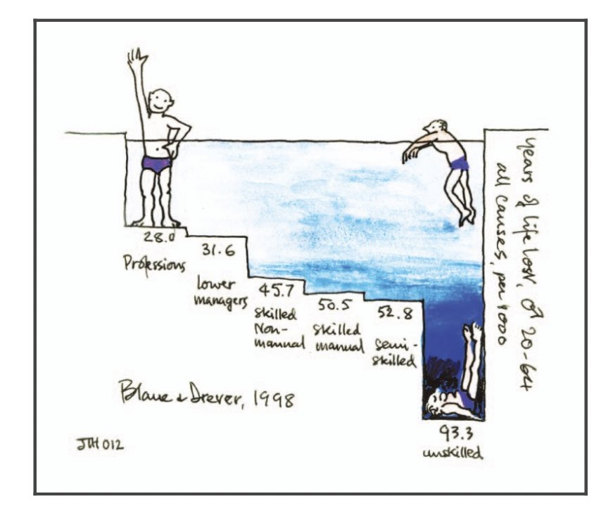

Over a decade later, it is still going strong and has produced over 40 reports covering issues such as:
- The cost-of-living crisis
- General practice in the time of COVID-19
- GP Recruitment and retention in deprived areas
- The contribution of general practice to improving the health of vulnerable children and families
- Palliative care in the deep end
- Social prescribing
- Coping with needs, demands and resources

Introduction
In November 2022, Deep End Wales was launched. A face-to-face event encouraged rich discussion, gave space and thinking time away from busy practices and fostered a supportive network in a safe environment.

The top 50 practices from the Welsh Index of Multiple Deprivation (WIMD 2019) were identified and invited to attend. This was subsequently extended to the top 100 practices. These practices covered areas of blanket deprivation. The group represented all Welsh health boards except Powys Teaching Health Board.

Twenty-three GPs and five practice managers attended the event, representing twenty five Welsh practices. Of the eighteen practices in Wales that have over 60% of their patients living in the most deprived 20% (60 - 82%), eleven (61%) attended the launch.
Following group discussions seven key themes were identified:
1. Patient literacy and advocacy
2. Recruitment and retention
3. Workload
4. Mental health
5. Complaints and low morale
6. Elderly and co-morbidity
7. Education and training

The purpose of this round table event was to take these issues and discuss them in greater detail (see Appendix I for program).

Participants were asked again to put up key issues on each of the seven themes using post it notes. Funding/finance and engagement were added to the themes. Additional comments were:

1. Patient Literacy and Advocacy
IT barriers decommissioning
Reduced communication, reduced continuity of care
Gypsy population - illiteracy
Language barrier
Social prescribers and CAB - allied services
Health inclusion patients getting a better deal than non-inclusion patients
How to influence lifestyle medicine
English not first language
Sexual health and young parents/first time single parents
No extra funding for double appointments
No way to show them on sitrep
Less digital literacy and ability to communicate remotely
Patients don't come back for structured care
Better support in implementing e-platforms, etc for access - making LIMITS acceptable

2. Recruitment and retention
Retaining reception/admin staff
Recruitment - GP advert out for 3 months, no replies
Need to make general practice appealing again
Attracting and retaining workforce
Allowing GP trainees to chose Deep End practices
Staff retention and employment - all areas - clinical and admin

3. Workload
Cost of locums
Staff absence
Flexibility to be adaptable to change depending on what presents e.g. Strep outbreak
How to manage workload
Health board demands - length of notice (short)
Increased demand
Highlight the increased workload related to deprived areas - highlight patients suffer
Staff absence (stress, illness) means increased workload for remaining staff
Access and patient expectations
Role of PA/ANP - involvement in Deep End
Equality - patient services not available to non-English speaking patients
How to improve GP numbers, how work is allocated/monitored
How do we encourage continuity of care while managing appropriate skill mix for our patients
Cluster work being decommissioned - increased unpaid work or decreased patient access to local services

4. Mental Health
Health board funded "1st contact service" cherry picking i.e. no ADHD
Lack of mental health services - CAMHS, PRAMS
Availability of psychologist
Health board services i.e. mental health and MSK services level changes at short notice
Lack services, wait times
To also connect with drug and alcohol services
Difficulty in admitting urgent cases e.g. funded
Lack of timely access to secondary care services
Children and teenagers, lack of service
Need provision for consistent MH nurses
Communication with mental health teams

5. Complaints and Low Morale
Zero tolerance policy put in place to support our staff
More complaints, easier access for patients to complain, very timely process
Media attention
Time lost on inappropriate complaints
Funding/time for CPD
Google reviews - fuel unhappiness
Violent patients

6. Elderly and Co-morbidity
Lack of emergency care - WAST 999 delays
Ambulances not turning up
High deprivation - high co-morbidities
Isolation and reluctance to accept help
Housebound patients - so they get the same service
Lack of understanding from secondary care about increased disease burden affecting the most deprived areas
Having to manage more complex medical conditions in primary care
Need health board support - nurses, admin - to monitor chronic disease patients
Look at allied professionals - paramedics, district nurses, pharmacists, etc

7. Education and Training
Decommissioning of Menopause Service - Cardiff East
Barriers to nurse training - annual courses too infrequent
Lack of funded training across all sectors in primary care
Need health board support in training e.g. locum payments for Deep End practices
Look at longer term, investment
Support for trainees/support to establish training practices
Fellowships - also R&R
More time to be allocated in general practice towards education rather than everything being done in "own" time
CPETs not adequately funded
Patient Education

Funding/finance
Decommissioning of teen talk and patient education - Cardiff East
Lack of information/understanding re:collaborative and service commissioning
No CPET training
Wellbeing 4U funding cut
Cluster funding not taking into account deprivation or disease prevalence
Funding practices - deprivation based
Is there more of an explanation of how Carr-Hill formula is made up
Funding - currently biased towards rurality, change to by deprivation
Funding for staff training and "breakout" for violent patients
Restructuring of cluster meetings - participation variable

Discussions on key issues
Attendees broke up into groups, depending on particular interests, to discuss a combination of some of the key themes. Each group had a facilitator who summarised the points and fed back. Findings are transcribed below:

Workforce, Retention and Recruitment
Issues:  There are problems at every level  Recruitment and engagement is poor  There is a deterioration of work structure  Minimum wage is an issues | Potential solutions:  Training practices find it easier to recruit staff  Encourage trainees to work in the top 100 Deep End practices  (There are financial incentives and golden handshakes in rural practices that are not provided in areas of deprivation)  Going back to face to face appointments will give structure

Well-being and Complaints
Issues:  All complaints have to be dealt with, even if trivial, which is time consuming  If staff members are named in complaints, this can affect their morale  Patients may have unrealistic expectations  Adversarial society  Low threshold for inviting people in for a meeting  Google review - digitally vulnerable | Potential solutions:  Identify complaints lead in each practice  Hold "significant events" meetings and provide support  Liaise with health boards as they have a generic responsibility for complaints  LHB complaints team collaboration - generic response to complaints, positive press, institutional response, press liaision, dealing with social media  RCGP and health boards could feed positive stories into the media  Local health boards have a communications team but they are often ineffective  Soft language in written response  Staff training - ongoing training  Supportive practice - perks such as Costa cards, acknowledging birthdays

Workload and Mental Health
Issues:  Staff often don't have the time or space to overcome barriers  Practices cannot shut for learning  Staff are burnt out  Staff leaving prevents continuity of care  Language barriers can also prevent good care  Cardiff's urgent primary care centre does not see patients who require translation e.g. refugees  Lack of interface with secondary care.  Patient results are given to Consultants and not GPs  Patients medical complexity | Potential solutions:  Protected learning time for all staff, not just GPs  Remind health boards that protected learning time is essential, especially for Deep End practices  Patient education  Re-engagement  Compassionate communities

Funding
Issues:  We don't know how it works - Carr-Hill, weighting, rurality, no-one knows what others get  GP contract funding is divergent across the nations - postcode lottery  Clusters are not working for practices in deprivation - they are too short term  Pan clusters work from the top down and don't take grass roots into account.  Deep End practices don't have private income  Backdate uplifts are guesswork  No weighting for deprivation  Practices lose money if they move  Practices are less likely to do private work due to time and ethics  Workload excludes other sources of income | Potential solutions:  Explanations and transparency of funding.  Change funding to be more upfront rather than retrospective.  Value goodwill in Deep End practices.  Improved pay and pay scales for non-clinical staff.  Start an online group to lobby for better pay  Ask GPC to clarify funding  Partnership model for secondary care work e.g. NCN's paying for phlebotomy but doing it themselves  Minimum wage uplift, equity of pay  Introductions/tasters into new ways of working  Set up as a CIC e.g. Red Kite, Powys  Research provides signficant income  Set up a lobby group to write to GPC - ask for clarification of spend, explanation of GMS funding  Find allies e.g. patients  Make pay equivalent to NHS pay but without banding  Value the goodwill input to the Deep End  Clinical leadership is key  Set up meaningful targets  Weight cluster funding  Make clusters more grassroots/community led

Patient Literature and Advocacy
Issues:  Refugees with limited English.  Variability in what inclusion services can provide and what resources they have.  Improving patient education is harder and costly  Patients need help to understand the health care system.  Difficult for small practices to engage due to no long term funding  Lack of access to equipment  Lack of confidence to use equipment  E-consult and telephone appointments can feel more risky  People less able to navigate system  Can be difficult to reach people especially health inclusion groups  Resources in inclusion services are not in Deep End practices but may be doing the same service  Social prescribing is short term, culture change, inconsistent and less used by the most in need  Uptake of health promotion e.g. vaccines for children takes time and expertise  Outreach to community groups can led to a risk of increased demand and are the  primary care team the right people  The appointment system is a barrier to the more vulnerable but drop ins are not sustainable | Potential solutions:  Engage with patients at an earlier stage in their illnesses  More time with patients  Work with those with expertise in social prescribing - Frome Model of Enhanced Primary Care.  Appointments for young people to explain the health care system.  Counsellors to advocate for patients.  Clusters try to engage with other practices.  RCGP to feed back to Welsh Government, ask for more support.  Attend AMD's monthly meeting to bring attention to Deep End issues  Interview primary care staff in Deep End practices about what they want to get out of the Deep End project and what's preventing them from engaging.  Access tools and resources as a Deep End movement, rather than as individuals  Increase an enhanced service for inclusion groups  Start patient education from a young age - one to one's with teenagers  - explain the importance of immunisations  - systems literacy  - provide everything they need to know appropriate to their needs  Cluster level with funding  Link up with others who can do it  - psychological wellbeing practitioners  - link workers  - community connectors  These pathways need to flow and connect with the right person  Practices need space and time  Long term - core business and funding  Consistent access  Consider CICs - different employees and income  Engage with AM's, counsellors, PHTs, patients

Medical Complexity
Issues:  Not just elderly  Time to make a difference  Crisis management  Loss of attached nurses to primary care team  Team working primary/secondary care  Communication across interfaces  Different solutions across health boards  Staff turnover/effectiveness  Pay rates  Autonomy vs health board agenda  Ownership and risk of complex complicated care  Continuity of care  Reliance on untrained carers/medications  Fragmentation of services  Balancing treatments different systems  Different specialists  Specialist generalists  Working beyond capability  Patients not controlling disease/looking after health  - disengagement  - other challenges  - ACEs  - liftestyle  - complications  Disinvestment  - funding pulled  - staff change  - no control over other services | Potential Solutions:  Patients - education, public health, continuity of care social prescribing, community resources to support patients, prevention across sectors  Compassionate communities and carers to prevent readmission  Link with voluntary agencies  Preventative medicine  Easy referrals to services to prevent crises  Change champions - funding for backfill

Workload/Education
Issues:  Lack of space  Time commitments - busier practices  Reimbursement or not  Barrier to courses - frequency, flexibility, recognition, accessibility  Robbing Peter to pay Paul  PLT and lunchtime - loss of cover, loss of protected time for personal and staff development  Peer supports  Head space  Retention after training  Pay - secondary care  Other industries Asda  Loss cluster funding  Imposed projects  Staff meetings and morale  Area specific learning needs  Disseminating information amongst team  Affordable and appropriate cover/locum GP and team  Demand - patients, LHB, targets, secondary care work  Burnout  Continuity  Communication | Potential solutions:  Buddying practices to provide cover  Cluster cover  Continuity  - patient choice - reception staff, alerts  - MDT meetings  IT systems e.g. Accurx  Protected time for learning  Funding for fellowships/team  Deep End to write a letter regarding UPC not seeing non-English speaking patients  Input to GP training and mentorship for new partners  Dump secondary care workload from the waiting list

Workforce
Issues:  Recruitment at every level - doctors, staff, difficult engagement with LHB, poor resource allocation, fire fighting decision  No interest from clinical staff  Clinical space as a barrier to recruitment  Deep seated infrastuctural problems that are a barrier to recruitment  Staff wage uncertainty - minimum wage changes  Funding uncertainty, constant changing playing field  Deteriorating local health infrastructure further affecting morale  Ageing workforce  Work life balance - ongoing  Erosion of GP profile from the media  Deteriorating time constraints  Collaborative structures poorly funded (NCNs in Cardiff non-functional)  Devolving work to other practitioners is a false economy  Erosion of public service | Potential solutions:  Training practice - trainee sharing  Better funding to collaborative networks (NCNs) and more focus  Unified pay structure for clinical staff (agenda for change versus practice contact)  Financing good practice - partnership incentive  Look at pharmacy (as a resource)  Funnel trainees into top 100 practices  Extra deanery funding  Obligatory or strongly encouraged distribution  Nationally reimbursed properly for training  Shut door policy (lunchtime and 1 afternoon)  Public service attitude  Push back against unfunded services  Move back to F2F - re-establish equitable practice  Reliable service provision from LHB  Marketing of GP profile - equalize profile of GPs with hospital consultants  LHB capping of locum rates (work collaboratively across Wales or geographical area)

How do we move forward?
The group felt that putting topics on a dedicated Teams page would be the most accessible way forward. People can chose to participate in the discussions that they are interested in. This can also act as a repository for files such as minutes of meetings and information.

Virtual lunchtime meetings, lasting approximately an hour, were deemed the most likely to encourage participation.

