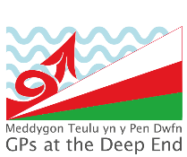
Welsh GPs at the Deep End Project

Health Equity Study Day

Tuesday 17th March 2026
The Towers Hotel, Swansea

Event Programme
09.30 - 10.00 | Welcome  Working in the Deep End – a Welsh Perspective | Dr Neil James  Chair, Deep End Wales
10:00 – 10.30 | ‘Teg I Bawb’ Training | Mrs Joanna Watts-Jane  Vice Chair, Deep End Wales
10:30 – 13.00 | Interactive Workshop  (with Coffee Break) | Made by Mortals
13:00 -14.00 | Lunch
14:00-14.45 | Keynote Address  Social Justice and Health Equity | Prof Sir Michael Marmot
14.45 – 15.15 | Liver Disease and Inequality | Dr Andrew Yeoman
15:15 – 15:30 | Coffee Break
15:30 – 16.00 | Liverpool Advice on Prescription Scheme | Debbie Nolan  Dr Clare Mahoney
16.00 – 16.25 | ‘Teg I Bawb’ – a strategic action plan | Dr Rahul Dalal  Dr Kerry Bailey
16:25 – 16:35 | Evaluation and Close

